ATTENDANCE POLICY



GRANGE PARK SCHOOL 2027-28

Approved by Governing Body | Date: July 2026
Last reviewed on | Date: September 2026
Next review due by | Date: September 2027
Person/s Responsible | Head teacher - Mrs R Madar  Attendance Manager - Mrs J Phull

STRIVE - LEAD - SUCCEED

Introduction & Background
Grange Park, in partnership with our parents / carers, will continue to be a successful school and your child plays their part in making it so. We aim for an environment which enables and encourages all members of the community to reach out for excellence. We strive to promote our values by instilling in our pupils, excellent behaviour for learning, monitoring pupil attainment and giving every child the best educational experience to ensure that they are secondary ready. For our children to gain the greatest benefit from their education it is vital that they attend regularly and be at school, on time, every day the school is open. We endeavor to make our school, part of the community in order develop a sense of belonging for our children and their families and furthermore, give them a reason to want to attend school every day.

This policy is written with the above statement in mind and underpins our school ethos to:
- promote children’s welfare and safeguarding
- ensure every pupil has access to the full-time education to which they are entitled
- ensure that pupils succeed whilst at school
- ensure that pupils have access to the widest possible range of opportunities at school

This policy has been developed in consultation with school governors, teachers, the Local Authority and parents / carers. It seeks to ensure that all parties involved in the practicalities of school attendance are aware and informed of attendance matters in school and to outline the school’s commitment to attendance. It details the responsibilities of individuals and groups involved and the procedures in place to promote and monitor pupil attendance.
This policy aims to raise and maintain levels of attendance by:
- Promoting a positive and welcoming atmosphere in which pupils feel safe, secure and valued
- The delivery of an engaging and relevant curriculum
- Raising awareness of the importance of good attendance and punctuality
- Ensuring that attendance is monitored effectively and reasons for absences are recorded promptly and consistently

This document should be read in collaboration with the DFE publications below:
• Working together to improve school attendance
• Summary table of responsibilities for school attendance

Why is regular attendance so important?
Regular attendance ensures children get the best start in their education. Missing school disrupts the sequential nature of learning, creating gaps in foundational skills like reading and math. Consistent presence also builds vital social skills, emotional well-being, and positive routines that safeguard children and set them up for future success.
Regular school attendance is critical for several key reasons:
- Academic Achievement: Primary education lays the vital building blocks for all future learning. Research shows pupils who attend consistently are far more likely to grasp key concepts and reach expected academic standards.
- Social & Emotional Growth: School is where children form early friendships, build teamwork skills, and grow in confidence. Frequent absences can lead to children feeling disconnected or isolated from their peers.
- Routine and Life Skills: Attending every day helps children establish a sense of belonging and a stable routine. It also instills essential life traits like punctuality, reliability, and responsibility.
- Safeguarding: Consistent attendance allows educators to monitor a child's wellbeing, identify needs, and provide early support, which acts as a protective factor against wider risks.

Promoting Regular Attendance
Helping to create a pattern of regular attendance is everybody’s responsibility – parents/carers, pupils and all members of school staff.

To help us all to focus on this we will:
- give you details on attendance in our regular newsletters
- report to you on how your child is performing in school, what their attendance and punctuality rate is and how this relates to their attainments via parent evenings and through a school report at the end of the academic year
- celebrate good attendance by displaying class certificates
- reward 100% attendance through weekly class certificates and individual certificate at the end of the academic year

School Attendance Target
The school target for attendance is 97% and above and in order to improve attendance, you and your child/children have an important part to play in meeting these targets. The minimum level of attendance for our school is 96% and we will keep you updated regularly about progress in regard to this percentage both on our newsletters, on the website and letters sent.

Our target is to achieve better than this as we know that excellent attendance is the key to successful education and we believe our
pupils can be amongst the best in Hillingdon. Throughout the school year we monitor absences and punctuality to show us where improvements need to be made.
The following is a summary of our Attendance data:’

Trends:
Relative Performance:
Cohorts: We are determined to improve the attendance of our children who are receipt of pupil premium funding.
Resources: We will continue to use our MIS systems to track attendance patterns so we can put actions/ interventions into place and then measure for impact.

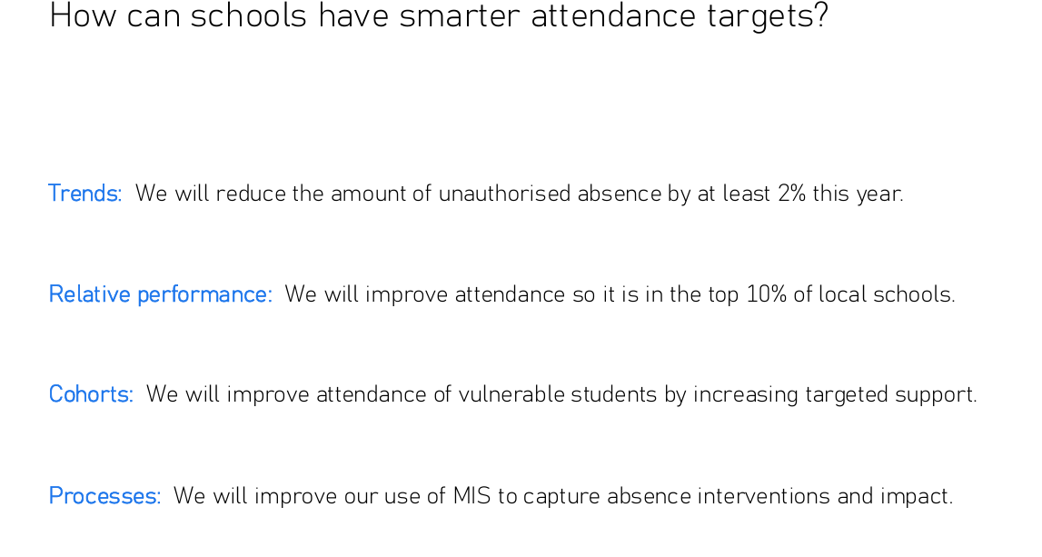
Understanding types of absence
Every half-day absence from school has to be classified by the school (not by the parents/carers), as either AUTHORISED or UNAUTHORISED. This is why information about the cause of any absence is always required by contacting the school by 8.30am for each day of absence on the Attendance line 020 8353 4265 – Option 2.
Authorised absences are mornings or afternoons away from school for a good reason such as illness and medical appointments which unavoidably fall in school time.

For medical appointments, Parents/Carers need to provide proof of the appointment in advance. If it’s an emergency appointment at any medical profession, please request an attendance card as proof.

Unauthorised absences are those which the school does not consider reasonable and for which no “leave" has been given. This type of absence can lead to the Local Authority (Attendance Support Team) using sanctions and/or legal proceedings.
This includes:
- parents/carers keeping children off school unnecessarily
- truancy before or during the school day
- absences which have never been properly explained
- children who arrive at school too late to get a mark
- shopping, looking after other children or birthdays
- day trips and holidays in term time which have not been authorised
- excessive illness without medical evidence

Whilst children may be off school because they are ill, it also happens that children can be reluctant to attend school. Any problems with regular attendance are best sorted out between the school, the parents/carers and the child. If your child is reluctant to attend, it is essential that you do not cover up their absence or give in to pressure to excuse them from attending. This gives the impression that attendance does not matter and usually makes things worse.

The Head teacher reserves the right to exercise her final discretion based on the evidence provided.

Telephone Numbers
There are times when we need to contact parents whether it be in an emergency or about absence, so we need to have at least three up to date contact numbers at all times. Please ensure that if you change a mobile number or your home number that the school is informed immediately.

Punctuality
Poor punctuality is not acceptable. If your child misses the start of the day they can miss work and does not spend time with their class teacher getting vital information and news for the day. Arriving late for school disrupts lessons, can be embarrassing for the child; and can also encourage absence.

How we manage pupils who are LATE:
- The school learning day starts at 8:40am (the school gates on Balmoral Drive open at 8.30am and the class room doors open at 8.40am). We expect your child to be in class on time.
- The school gates will be closed at 8.55am and children arriving after this time must be brought, by an adult, to the main reception through Lansbury Drive.
- In accordance with the Regulations, if your child arrives after 9am they will receive a late mark, however if they arrive after 9.30am they will receive a mark that shows them to be on site, but this will not count as a present mark and it will mean they have an unauthorised late mark on the Attendance Register. This may mean that you could face the possibility of a Penalty Notice if the problem persists
- If your child has a persistent late record you will be asked to meet with a member of the Senior Leadership team to resolve the problem. However, please be aware that you can approach us at any time if you are having problems getting your child to school on time. (Please take note of the punctuality board in the playground and in the main reception area).
- Hometime lateness: Please ensure your child in collected on time as gates will be closed promptly at 3.30pm daily and 4.30pm for afterschool clubs. Please ring prior to 3pm if you are going to be late or if you want another person to pick up your child. If you have not picked your child up by 3.40pm they will be put in our Wrap Around Care provision and then charged in accordance with their payment policy.

Start and finish times:
In Nursery: AM: Start time - 8:30am & Finish time 11.30am
PM: Start time - 12.30pm & Finish time 3.30pm
Reception to Year 6 - Start time - 8.40am
Reception, Year 1 and 2 - Finish time 3.15pm
Year 3 , 4, 5, and 6 - Finish time 3.20pm

Attendance Contracts and Attendance Panel
Grange Park School follow the Local Authority, Attendance Support Team guidance for parenting contracts and attendance panels

Attendance Contracts
- To work in partnership with the parent(s)/carers
- Formal written agreement between a parent/carer and either the school of local authority to address irregular attendance at school or alternation provision
- Parents cannot be compelled to enter a parenting contract and they cannot be agreed in their absence.

Attendance Panel
- A formal intervention
- Takes place when a parent/carer has failed twice to attend an organised meeting to discuss attendance and a parenting contract was to be offered
- The attendance panel agreement is held in the parent/carer’s absence and agreed by the attendance officer and responsible senior leader.

Persistent Absenteeism (PA)

A pupil becomes a ‘Persistent Absentee’ when they miss 10% or more schooling across the school year for whatever reason. Absence at this level is doing considerable damage to any child’s educational prospects and we need parents/carers full support and co-operation to tackle this.

Penalty Notices for Poor Attendance & Holidays taken during term-time

The school will make every attempt to contact the parent / carer by telephone and in writing. In the first instance we would invite them to discuss attendance unless the absence relates to leave in term time without permission. Where all other avenues have been exhausted and support is not working or not being engaged with, attendance may be enforced where necessary through statutory intervention or prosecution to protect the pupil’s right to an education. A referral may be made to the LA under the following circumstances based on the national framework for penalty notices.
A single consistent national threshold for when a penalty notice must be considered of ten sessions (usually equivalent to five school days) of unauthorised absence within a rolling ten school week period. This may span different terms or school years. This will include unauthorised absence for lateness Code U.
It is a rule of this school that a leave of absence shall not be granted in term time unless there are reasons considered to be exceptional by the head teacher, irrespective of the child’s overall attendance. All requests for exceptional circumstance leave must be put in writing to the headteacher. This letter must contain: The reason for the request, the dates of absence, including the return date, evidence relating to the reason for booking and details of any bookings made. Examples of the type of evidence required may include evidence of the date of a flight booking and evidence of family bereavement abroad. Where circumstances are considered to be exceptional the school may choose to only authorise some of the days requested.

Where a parent removes a child when the application for leave was refused or where no application was made to the school, the issue of a penalty notice may be requested by this school. The fundamental principles for defining ‘exceptional’ are events that are “rare, significant, unavoidable and short”. By 'unavoidable' we mean an event that could not reasonably be scheduled at another time.

- A term time holiday taken without permission would count towards the ten sessions

- A national limit of two penalty notices that can be issued to a parent for the same child within a rolling 3-year period. At the third (or subsequent) offence(s) other legal prosecution will be considered
Penalty notices are issued to each parent or carer for each of their children for example two parents with three children would receive a total of six penalty notices, one parent with two children will receive a total of two penalty notices.
From September 2024 each penalty notice is £80 if paid in the first 21 days, from days 22 to 28 the fine doubles to £160 for each penalty notice.
For the second offence issued to the same parent for the same child within a rolling 3-year period will be charged at a higher rate of £160 for days 1 – 28, with no option for this second offence to be discharged at the lower rate of £80.
The Attendance Support Team has asked us to point out that it is not possible to pay these fines by instalments or lower the cost when they have increased, or to simply fine one parent.
Payment can be made online and instructions on how to pay are included on the penalty notice letter.
If a penalty notice is not paid or the Attendance Support Team assesses that that the level of absence warrants court action, the local authority will arrange for a court hearing.
There are a range of sentencing options available to the magistrate including the maximum penalty of a fine of up to £2500 per parent for each offence as well as the possibility of up to three months in prison.
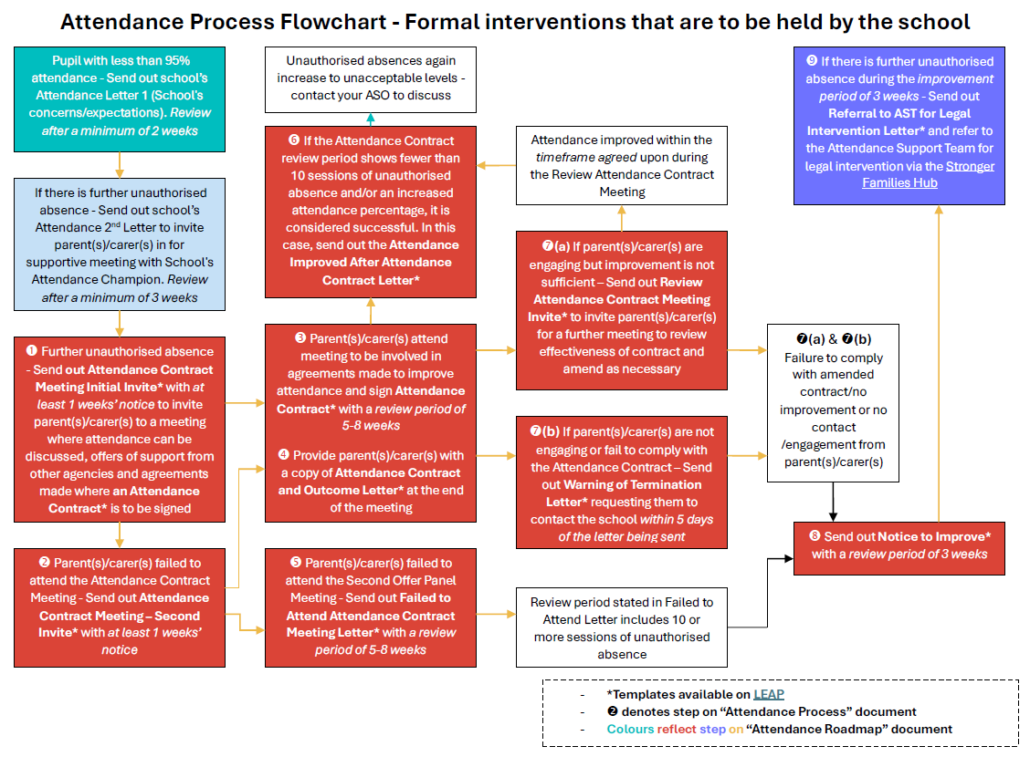

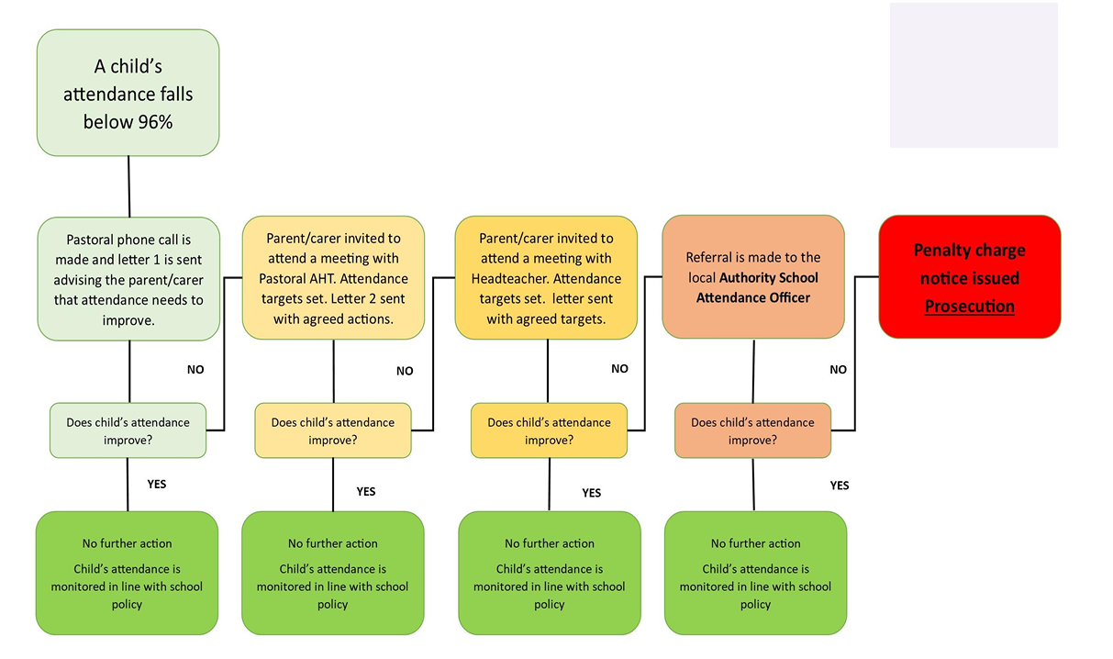
Performance Licences

The applicant for a Performance Licence (usually the Production Company or theatrical agent) is obliged to seek the view of the school when applying for an absence request. Such a request will only be considered by the school when the child’s attendance is at least 90% and the child is making at least expected levels of progress. A request may be declined if either of these thresholds is not meet or if the timing of the requested absence could be detrimental to the child’s education.
Deletion from Roll
For any pupil leaving Grange Park School, other than at the end of year 6 parents/carers are required to complete a ‘Pupil Exit Form” which can be obtained from the school office. This provides school with the following information: Child’s name, class, current address, date of leaving, new home address, name of new school, address of new school. This information is essential to ensure that we know and safeguard the whereabouts of all our pupils. In such cases, the school will submit an online deletion form to the Attendance Support Team to complete the removal of a pupil off roll.
Children Missing Education
In Children Missing Education - Statutory Guidance for Local Authorities (2016), children missing education are defined as those who are not on a school roll or receiving suitable education otherwise than at school. Those who are regularly absent or have missed 10 school days or more without permission may be at risk of becoming 'children missing education'.
There will not always be a safeguarding concern for children who are missing education. Most children are moving schools supported by their parents/carers, schools and local authority admissions services. A smaller number, however, are at risk of dropping out or disengaging from education and being out of school, they are at risk of exploitation, going missing and significant harm.
In the circumstances of a child going missing who is not known to any other agencies, the Head teacher should inform the Children Missing Education (CME) Officer of any child who has not attended for 10 consecutive school days without provision of reasonable explanation which can result in the child being removed from the school roll. Prior to doing so, the school will have made enquiries to ascertain whether the child is still residing at the home address and is not attending or whether the child is missing.
Equal Opportunities
We ensure that every member of the school community experiences equal opportunities, irrespective of ethnic origin, race, religion, colour, nationality, political beliefs, disability, age, sex or sexual orientation and that every member of the school community is valued as an individual and that everyone understands that stereotyping, discrimination, prejudice and racism will not be tolerated.

Roles identified who have Responsibility for Attendance:

Role of the Headteacher – Mrs Madar
- Is responsible for a strategic oversight of attendance procedures, developing and maintaining a whole school culture that promotes the benefits of high attendance.
- Ensures strategies are in place to promote and implement the policy throughout school.
- Consider leave of absence requests of up to five days, applying the principles outlined in this policy and ensuring that the absence will not impact on key assessments or events.
- Notifies parents that, if a student fails to attend regularly, they are committing an offence in law.

Role of the Designated Attendance Lead – Miss Allen:

- Ensure Attendance is everyone’s business
- Coordinate resources: Distribute policies, procedures, and attendance resources
- Provide advice: Offer advice and support on attendance to staff and volunteers
- Manage concerns: Help key staff members to handle attendance concerns
- Make referrals: Refer high level attendance concerns on to other key agencies
- Develop and review plans: Create and maintain the organisation’s attendance plan
- Provide training for staff where required
- Promote quality: Promote quality and care, and appropriate learning and development

Role of Phase Leaders / Senior Leaders / Year Group Leaders for:

- Create a welcoming and caring environment for children to enter at the start of the day.
- Ensure classteachers are following the correct procedures for registration
- Ensure that they have an understanding of children who are vulnerable for attendance
- Support teachers talking to families where attendance is a concern
- Present certificates for full attendance in Assemblies and celebrate attendance of key children
- Report and concerns to the Designated Attendance Lead / Attendance Officer around attendance of children
- Be role models for good punctuality and attendance.

Role of Classteachers:

- Create a welcoming and caring environment for children to enter at the start of the day.
- Follow the correct procedures for registration and record attendance accurately
- Ensure that they have an understanding of children who are vulnerable for attendance
- Communicate respectfully to parents/ carers of children whose attendance is concerning
- Welcome children positively after a period of absence and ensure that they are supported to catch up with learning missed
- Report and concerns to the Designated Attendance Lead / Attendance Officer around attendance of children
- Be role models for good punctuality and attendance.

Role of Parents / Carers:

- ensuring regular and early bed times
- helping with homework
- having uniform and equipment prepared the night before
- providing a healthy breakfast
- reporting any academic or social concerns promptly
- retaining open and honest communication with your child’s school
- send your child in, even if they unwell (vomiting, fever and diarrhoea are exceptions to this)
- alert the school if your child is feeling unwell so the medical team can monitor them regularly throughout the day
- being positive about school (even if your own experience was less than positive)
- encouraging your child to develop their friendship circle

Role of Attendance Manager – Mrs Phull

- First-Day Response: Contacting parents of absent pupils by phone or text to verify reasons for absence, documenting explanations, and recording the correct registration codes.
- Data Analysis, Tracking and reporting: Regularly running reports through the school’s management information system (MIS) to pinpoint students at risk of becoming persistently absent (below 90% attendance).
- Family Liaison & Intervention: Engaging directly with parents to break down barriers to attendance, which may include home visits.
- Safeguarding Compliance: Elevating unresolved attendance issues to senior leadership, acting as the primary liaison with local authorities, and flagging potential child protection or welfare concerns to the Designated Safeguarding Lead
- Implement the Attendance Policy and the Hillingdon Local Authority procedures
- Readily communicate with parents with regards to attendance matters and celebrate improved attendance with them
- Readily communicate with children with regards to attendance matters and to champion and share success stories of children who have shown resilience and have improved attendance.
- Implementing reward systems around attendance

Role of the Governor

- Policy Approval & Ethos: The governing body formally reviews and approves the school’s attendance policy, ensuring it aligns with national guidance (such as the Department for Education's Working Together to Improve School Attendance). They ensure the policy promotes an ethos where high attendance is valued and barriers to learning are actively addressed.
- Data Monitoring: Governors regularly review attendance data—including persistent and severe absence trends—to understand the full picture. By analysing this data, governors ask targeted questions to ensure school leaders are focusing improvement efforts on specific cohorts or individual pupils who need the most support.
- Holding Leaders to Account: The governing body ensures that school staff receive adequate training on attendance and that school leaders are fulfilling their statutory duties. This includes verifying that the school has a dedicated senior leader championing attendance and that interventions (such as letters or meetings) are having an impact.
- Link Governors: Appoint an "Attendance Link Governor". This specific governor works closely with the school's attendance lead to understand daily challenges, review data in depth, and report back to the full governing body

Key names and numbers:

Mrs R Madar - Head teacher
Mrs J Phull - Attendance Manager
Mrs R Taylor - Governor with responsibility for Safeguarding and Child Protection

Contact details for attendance: Mrs Phull – Tel: 020 8353 4265 (Option 2) / Email: attendance@grangeparkschool.co.uk

Summary

The school has a legal duty to publish both its absence figures and its Attendance Policy to parents/carers and to promote attendance. School attendance data must be available to the Local Authority and the Department for Education. Equally, parents/carers have a duty to make sure that their children attend school.

All school staff are committed to working with parents/carers and pupils as the best way to ensure as high a level of attendance as possible which in turn optimises your child’s attainment. Please support us and your child in order to achieve this.

Policy Review
This policy will be reviewed annually by the Governing Board to ensure it is up to date with current legislation, statutory guidance and best practice.

Relevant Policies

- Child Protection Policy
- Safeguarding Policy
- Supporting Pupils with Medical Conditions Policy.

Approved by: FGB
Date approved: July 2026
Review Date: September 2027

Appendix
Attendance Action Plans

