Behaviour for Learning Policy

Grange Park School


Approved by Governing Body | Date: 17th July 2025
Last reviewed on | Date: 17th July 2025
Next review due by | Date: 17th October 2026

TABLE OF CONTENTS
Section | Item | Page number
1 | Vision and values | 3
2 | Legislation and Statutory Guidance | 4
3 | Safeguarding | 4
4 | Readiness to learn | 6
5 | Routines | 7
6 | Expectations of places and visits | 8
7 | Rewards and sanctions | 9
8 | Roles and responsibilities | 12
9 | Reasonable adjustments | 14
10 | Zones of regulation | 15
11 | Restorative practice | 16
12 | Support provided in school | 17
13 | Use of reasonable force and restrictive intervention | 18
14 | Searching, screening and confiscated items | 20
15 | Permanent exclusions | 20
16 | Working with parents | 21
17 | Monitoring the policy | 22

- Vision and values

Our vision is to nurture well-rounded pupils who are ready to learn, emotionally literate, and equipped with the knowledge and skills they need to succeed both now and in the future. We believe that high standards of behaviour are central to a positive education and must be taught, modelled and supported across the school day.

At Grange Park School, we are committed to ensuring every child understands what is expected of them in a school setting. Our Behaviour Policy provides clear, consistent guidance to help pupils make positive choices, recognise the impact of their actions, and contribute to a calm, respectful and inclusive learning environment. Through explicit teaching and daily routines, pupils gain a deep understanding of behaviour expectations and how these support their success.

Central to our approach is the belief that all behaviour is a form of communication. We use restorative practices to support pupils in reflecting on their actions, rebuilding relationships and learning from mistakes. This enables children to develop the emotional regulation and self-awareness needed to navigate school life effectively and respectfully.

We aim to develop pupils who are not only academically prepared for secondary school, but who also demonstrate empathy, resilience, and responsibility. As pupils move through our school, they are guided to recognise their role in the community and take increasing ownership of their behaviour and learning.

Ultimately, our vision is that every child will leave us with a strong foundation in both learning and character – confident, reflective and ready to meet the expectations of secondary school and beyond.

Our school values are rooted in the acronym STRIVE:
- Self-belief – we encourage pupils to believe in themselves and their ability to improve.
- Teamwork – we promote collaboration, communication and mutual respect.
- Resilience and Respect – pupils learn to persevere through challenges and treat others with kindness and dignity.
- Independence – we nurture pupils’ ability to think, act and reflect for themselves.
- Victory – we celebrate all forms of achievement, effort and progress.
- Empathy – pupils are supported to understand others' perspectives and repair relationships when harm occurs.
Our Behaviour Policy will enable our pupils to achieve this vision. The policy promotes high expectations, consistent routines and restorative practices to help children reflect on and learn from their choices. As outlined in the DfE’s Behaviour in Schools (2024), positive behaviour must be taught, modelled, and supported – especially for pupils who need additional help. We explicitly model, teach and reinforce our values through all aspects of school life.
We believe that leadership is not limited to titles, but a mindset that can be developed in all pupils. Whether through peer mentoring, classroom roles, or modelling kindness, our pupils are supported to lead with integrity and purpose.
In striving to be the best they can be, every pupil is supported to succeed – socially, emotionally and academically.

- Legislation and Statutory Guidance

This Behaviour Policy complies with the duties outlined in key legislation and statutory guidance. It reflects the requirements of the Education and Inspections Act 2006, particularly Section 89, which obliges headteachers to promote good behaviour, prevent bullying, and support pupil discipline. It aligns with the Equality Act 2010, ensuring reasonable adjustments are made to avoid disadvantaging pupils with disabilities or additional needs.

The policy also considers guidance from the Department for Education, including Behaviour in Schools: Advice for Headteachers and School Staff (2024) (DfE Guidance), and Keeping Children Safe in Education (KCSIE).

It should be read in conjunction with related school policies, including those on safeguarding, SEND, and exclusion, and is underpinned by our duty to safeguard pupils and promote high standards of behaviour that support learning and well-being.

- Safeguarding

At Grange Park School, safeguarding and behaviour are intrinsically linked. A calm, safe, and predictable learning environment is essential for all children to thrive. This Behaviour Policy supports our duty under Keeping Children Safe in Education (2024) (KCSIE) to provide an environment in which pupils feel secure, respected, and able to learn without fear of harm.
As outlined in the DfE’s Behaviour in Schools (2024) guidance, behaviour policies play a central role in safeguarding pupils. All staff are responsible for upholding behaviour expectations in ways that promote dignity, inclusion, and protection. Pupils are explicitly taught how to recognise and respond to unsafe situations, including through restorative responses where appropriate.

The Behaviour Policy sets a clear framework for responding to inappropriate conduct, including bullying, aggression, discrimination, and child-on-child abuse. These behaviours are not tolerated under any circumstances. Where concerns arise, they are addressed swiftly, proportionately, and in accordance with both the Behaviour Policy and Safeguarding and Child Protection Policy. The school ensures that all pupils understand what respectful behaviour looks like and how to seek help if they or someone else has a concern.

Every incident of behaviour is viewed through a safeguarding lens. If a child’s behaviour raises concern that they may be at risk of harm, staff follow school safeguarding procedures and consult the Designated Safeguarding Lead (DSL).

In this way, our Behaviour Policy is a key component of our whole-school approach to safeguarding and promoting the welfare of every child.

Child on child abuse

This school recognises that children sometimes display harmful behaviour themselves and that such incidents or allegations must be referred on for appropriate support and intervention.
Such abuse is unacceptable and will not be tolerated. To prevent child-on-child abuse and address the wider societal factors that can influence behaviour, the school will educate pupils about abuse, its forms and the importance of discussing any concerns and respecting others through the curriculum, assemblies and PSHE lessons.
The school will also ensure that pupils are taught about safeguarding, including online safety, as part of a broad and balanced curriculum in PSHE lessons, RSE and group sessions. Such content will be age and stage of development specific, and tackle issues such as:
• Healthy relationships
• Respectful behaviour
• Gender roles, stereotyping and equality
• Body confidence and self-esteem
• Prejudiced behaviour
• Sexual violence and sexual harassment always being wrong
• Cultures of sexual harassment
All staff are aware that pupils of any age and sex are capable of abusing their peers and will never tolerate abuse as “banter” or “part of growing up”. All staff will be aware that child-on-child abuse can be manifested in many ways, including sexting and gender issues, boys and girls being sexually touched or assaulted, and boys or girls being subjected to hazing/initiation type of violence which aims to cause physical, emotional or psychological harm. All staff will be made aware of the heightened vulnerability of pupils with SEND, who are three times more likely to be abused than their peers. Staff will not assume that possible indicators of abuse relate to the pupil’s SEND and will always explore indicators further.
Pupils will be made aware of how to raise concerns or make a report and how any reports will be handled – this includes the process for reporting concerns about friends or peers. If a child has been harmed, is in immediate danger or is at risk of harm, a referral will be made to children’s social care services (CSCS).

- Readiness to learn

At Grange Park School, we recognise the importance of providing our pupils with the tools and strategies to show a readiness to learn. We have refined our behaviour expectations further for our pupils by identifying indicators of positive learning behaviour. On our endeavour to support our pupils with independence and their next stage of learning, we encourage our pupils to foster behaviours that will enhance focus, improve classroom management, and support learning across all subject areas.

Poster will be edited to include pictures of pupils

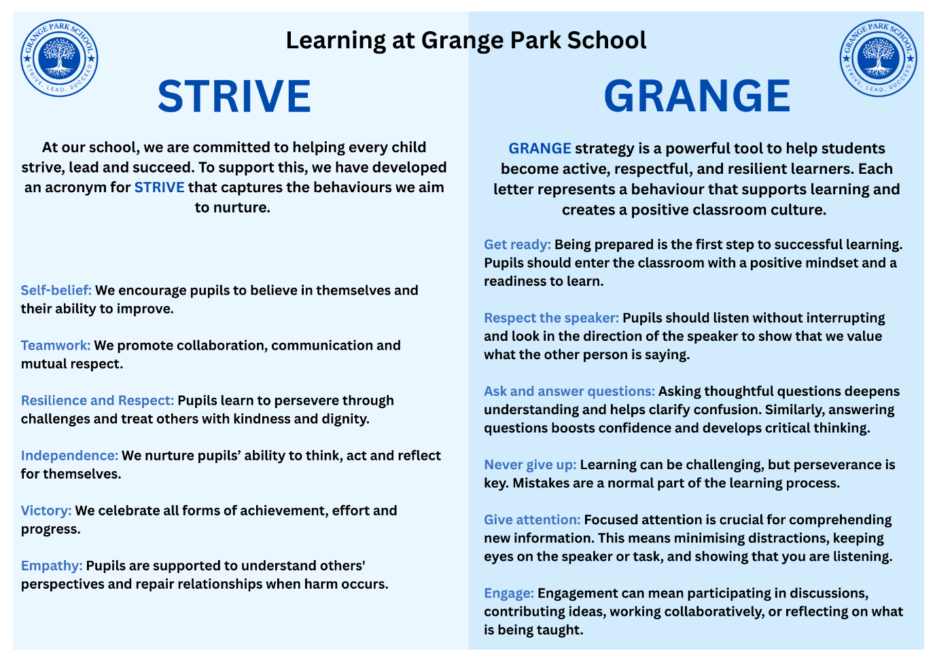

GRANGE is an acronym that encapsulates six key behaviours: ‘Get ready, Respect the speaker, Ask and answer questions, Never give up, Give attention, Engage’. The GRANGE strategy is a powerful tool to help students become active, respectful, and resilient learners. Each letter represents a behaviour that supports learning and creates a positive classroom culture.

The benefits of the GRANGE acronym is as follows:

Get ready: Being prepared is the first step to successful learning. Students should enter the classroom with a positive mindset and a readiness to learn. This includes having their books, pens, homework, and any other supplies organised and ready at the start of the lesson.

Respect the speaker: Whether it's a teacher, classmate, or guest presenter, respecting the speaker can be demonstrated through attentiveness. This includes listening without interrupting, looking in the direction of the speaker, and showing that you value what the other person is saying. Respectful listening helps build a safe and supportive learning environment for everyone.

Ask and answer questions: Questions are a sign of curiosity and engagement. Encouraging students to ask thoughtful questions deepens their understanding and helps clarify confusion. Similarly, answering questions—whether right or wrong—boosts confidence and develops critical thinking. These exchanges make learning active rather than passive.

Never give up: Learning can be challenging, but perseverance is key. Students should be taught that mistakes are a normal part of the learning process. The “Never give up” mindset builds resilience, encourages problem-solving, and helps students to become determined to push through difficulties instead of giving up at the first hurdle.

Give attention: Focused attention is crucial for comprehending new information. This means minimising distractions, keeping eyes on the speaker or task, and showing that you are listening. When students give their full attention, they not only learn better but also show respect for the lesson and those around them.

Engage: True learning happens when students are actively involved. Engagement can mean participating in discussions, contributing ideas, working collaboratively, or reflecting on what is being taught. When students engage with the content and with others, their learning becomes more meaningful and lasting.

By practising GRANGE, students take ownership of their behavior and learning. These six habits form the foundation of a productive, respectful, and motivated classroom community.

- Routines

At Grange Park School, consistent routines help create a calm, orderly environment in which children feel secure and ready to learn. Establishing clear, shared expectations enables all pupils to understand how to conduct themselves throughout the day, promoting positive behaviour and reducing disruption.

Start of the Day
Pupils line up calmly and sensibly each morning in their designated area. Staff greet pupils warmly, setting a positive tone for the day ahead. Pupils are expected to arrive on time, in full school uniform, and ready to learn.

Transitions
Pupils are expected to move around the school calmly and quietly. They line up promptly and sensibly at the end of break and lunch, ready to return to lessons. Transitions between lessons, into assemblies, or when moving around the building are managed through clear routines and adult supervision.

End of the Day
At home time, KS2 pupils line up and wait to be dismissed safely and respectfully. Early years pupils and KS1 pupils are expected to be sat sensibly and respectfully in their classrooms whilst they wait to be dismissed. Staff supervise dismissal to ensure it is calm, orderly, safe and secure.

Uniform
Pupils must wear full school uniform each day. PE kits must be worn on PE days and should consist of the school t-shirt and shorts or jogging bottoms. Uniform expectations support a sense of belonging, equity, and pride in our school.

Clear routines across the day support learning and reflect our high expectations for behaviour and conduct.

- Expectations of places and visits

At Grange Park School, we teach and reinforce high expectations for behaviour in all areas of school life. We believe that a calm, orderly and respectful environment allows everyone to feel safe, valued and ready to learn.

Corridors and Transitions
Pupils are expected to walk silently on the left and in single file when moving through the corridors and during transitions between lessons or areas of the school. This ensures learning is not disrupted and movement is safe for all.

Lunch and Shared Spaces
Pupils line up calmly and quietly when entering the lunch hall. They are expected to show good manners, follow instructions from staff, and maintain respectful behaviour in shared areas such as the hall, library and playground.

Classroom and Specialist Settings
Pupils are expected to listen and respond promptly to all adult instructions in the classroom. This includes specialist settings such as the swimming pool or MUGA, where clear listening and safe behaviour are essential.

Educational Visits
When offsite, pupils represent our school. Behaviour expectations remain high, and pupils are reminded that their conduct reflects on the school. They must follow staff instructions at all times and show respect to others in the wider community. Pupils must behave in line with the school behaviour policy.

Emergency Procedures
In the event of a fire drill or lockdown drill, pupils must remain silent and follow all instructions quickly and safely. Calm, quiet behaviour is essential in ensuring the safety of every member of the school community during these times.

These expectations are taught, modelled and practised throughout the year. By upholding these shared standards, we create an environment where all pupils feel secure, respected and able to learn.

- Rewards and sanctions

All members of staff have a responsibility to manage the behaviour of pupils under their care. This allows mutual respect to develop between pupils and staff and allows pupils to gain respect for school rules and expectations. Members of staff are aware of incidents which can be dealt with by themselves and those which require escalation to the Senior Leadership Team. Low level misbehaviour is to be dealt with by the member of staff who the issue is witnessed by or who is informed of the incident. Incidents which are persistent or of concern will be recorded on the CPOMS system by the member of staff involved. The incidents recorded on CPOMS will be regularly monitored by the SLT and the Behaviour Lead.

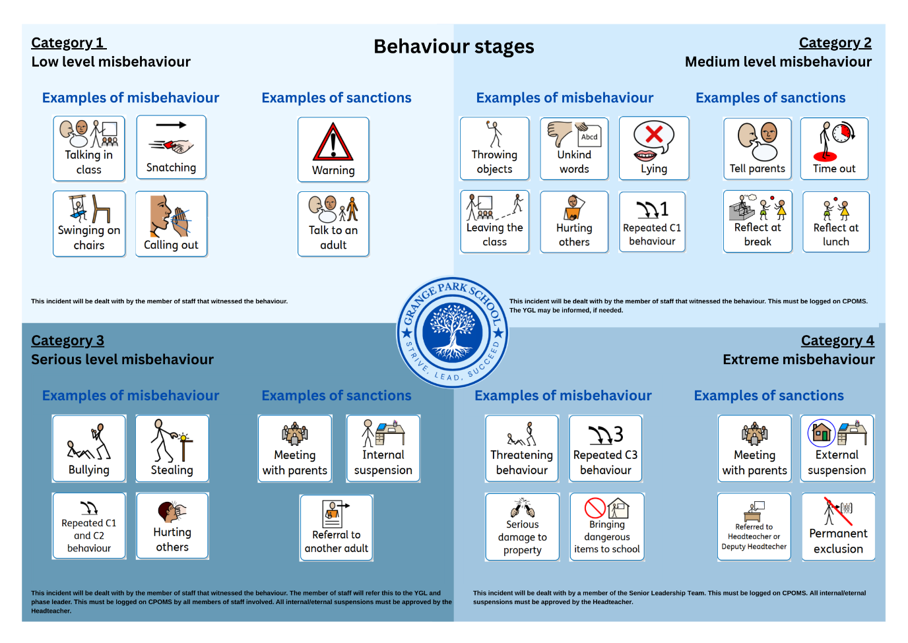
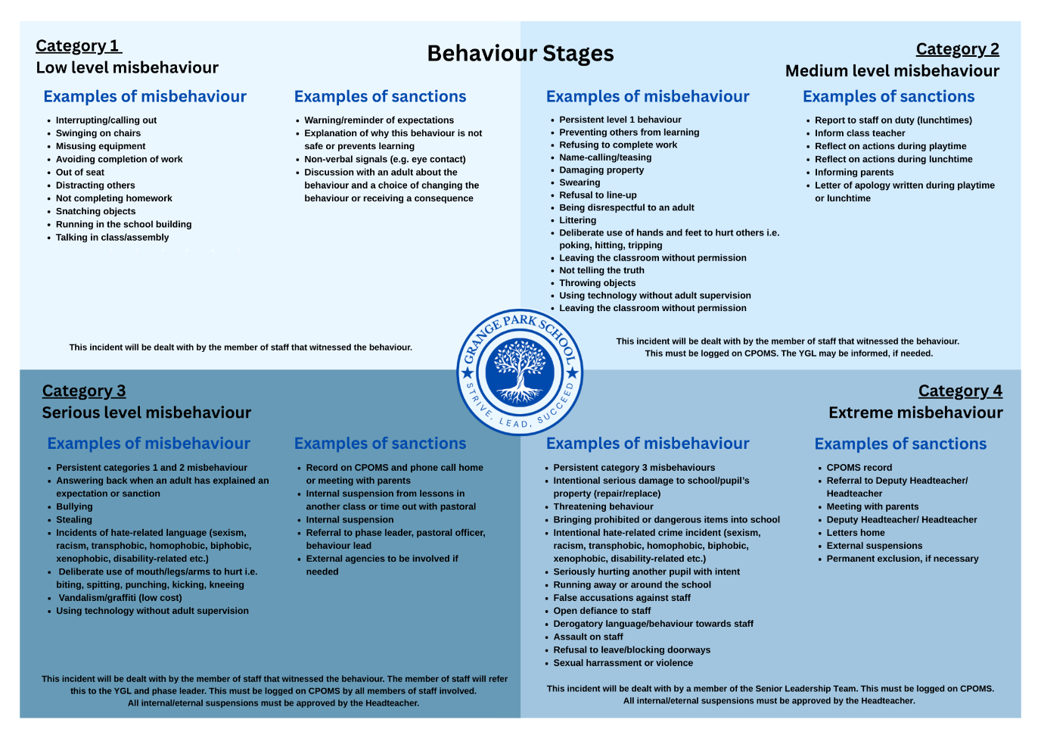
At Grange Park School, we believe that promoting and reinforcing positive behaviour is essential to developing a school culture in which all pupils can flourish. Our approach to rewards and sanctions is clear, consistent and supportive. It aims to help children understand the consequences of their actions, repair harm where appropriate, and make better choices in future.

Internal Suspension

Internal suspensions are temporary and will only occur in severe cases of misbehaviour. An internal suspension is when a pupil completes their work and has their lunch and break times in away from their class. Pupils will always be fully supervised by a member of the Senior Leadership Team or Pastoral Team and their work will be supplied by their class teacher.

External Suspensions

An external suspension is when a pupil is temporarily removed from the school premises. For the first five days of an external suspension, work will be provided and marked by the class teacher. Pupils cannot be suspended for over 45 days in one school year. Suspensions can occur for part of the day, for example, only at lunchtime if the pupil only misbehaves at lunchtime. Parents/carers will always be informed of the suspension.

Permanent Exclusions

Pupils who have not been able to change their behaviour despite multiple suspensions will be at risk of exclusions. This is permanent and means that the pupil will not be able to attend school. The local authority will become involved to arrange full-time education for the pupil from the sixth school day.

Where it is thought that a pupil is at risk of multiple suspensions or permanent exclusion, a plan will be implemented with the intent to support the pupil to improve their behaviour and meet their learning goals. The plan will be formulated alongside the school’s Behaviour Lead, Pastoral Officer and the pupil’s parents/carers.

A pupil will only be permanently excluded when a serious breach or persistent breaches of the Behaviour Policy have taken place or when allowing the pupil to continue staying in school would harm other pupils or staff members or significantly impact on the education of other pupils.

Persistent misbehaviour

Pupils displaying persistent category 1 and 2 behaviour, with five incidents occurring in a two-week timeframe, will be placed on report. Parents will be contacted for a meeting when the report period starts and weekly meetings will take place with relevant members of staff and parents. Pupils will be placed on report for two weeks and will have regular check ins with their phase leader. Pupils will need two days of no incidents to complete their cycle on the report. Pupils displaying persistent misbehaviour on report may receive an internal suspension. If a pupil is on report for four weeks without improvement, Behaviour Support will be contacted so that a Behaviour Support Plan can be put in place. Where pupils receive three internal or external suspensions, pupils will receive a Behaviour Support Plan and external agencies will be contacted to support with behaviour.

Mobile Phones

The school acknowledges that while many pupils own mobile phones, these devices can disrupt learning; therefore, a strict policy is enforced regarding all electronic devices. Pupils are not permitted to bring phones to school unless under specific, pre-approved circumstances. Year 6 pupils allowed to walk home may bring phones. Any phone brought for safety must be labelled, handed to the class teacher, and stored in the school office until home time. The school is not responsible for lost or damaged devices. Mobile phones must not be used on school grounds at any time, including before or after school, and are prohibited during lessons. Phones seen during the school day will be confiscated and only returned to a parent or carer. Refusal to hand over a phone when asked will result in further disciplinary action.
Social media

Incidents involving social media misuse, such as cyberbullying, online threats, or the sharing of inappropriate content, will be taken seriously and dealt with using both safeguarding and behaviour protocols. The school will notify parents regarding social media incidents that they may not be aware of. Where behaviour in school is impacted by social media incidents, the behaviour policy will be implemented.

- Roles and responsibilities

A positive, consistent and respectful behaviour culture can only be achieved when the whole school community works together. At Grange Park School, every adult and every pupil has a role to play in upholding and promoting high standards of conduct. Our behaviour expectations are explicitly taught, modelled and reinforced across all areas of school life.

Pupils

Pupils are expected to take responsibility for their own behaviour and conduct themselves in line with the school’s values and routines. They are taught to:
- Follow all school rules and instructions the first time
- Move calmly and quietly around the building
- Treat others with kindness and respect
- Treat others in line with our school values
- Be honest, reflective and open to making amends
- Accept the consequences of their actions
- Strive to improve and contribute positively to the school community
Pupils are encouraged to use self-regulation strategies and to seek help when needed. Through restorative approaches, pupils learn how their behaviour affects others and how to repair harm.

All Staff

All staff are responsible for promoting a culture of positive behaviour, modelling the school’s values, and applying the behaviour policy fairly and consistently. Staff will:
- Teach, model and reinforce clear routines and expectations
- Address all misbehaviour in a calm, consistent and proportionate way
- Praise and reward positive behaviour regularly
- Use restorative conversations to support learning and reflection
- Communicate with parents where appropriate
- Log behaviour incidents accurately and follow up as needed
- Work closely with senior leaders and the SENDCo to identify and support pupils who may require additional help
All staff receive training and support to implement the behaviour policy effectively and with confidence.

At Grange Park School, we expect staff to use calm, clear and positive language when addressing behaviour. Wherever possible, staff should state the desired behaviour, rather than focusing on what not to do. For example, saying “I’d like you to walk, please” instead of “Stop running.” This approach reduces confrontation, models respectful communication, and helps pupils understand expectations more clearly. Staff should use consistent, scripted phrases to reinforce routines and support emotional regulation. Positive scripting is part of our whole-school behaviour culture and supports our aim of creating a calm, safe and inclusive environment for all pupils. Positive scripting also allows pupils to process one instruction instead of identifying the behaviour they should not be displaying and then attempting to understand what behaviour should be displayed.

Headteacher

The headteacher is responsible for:
- Determining and upholding the school’s behaviour policy, in line with the Education and Inspections Act 2006
- Ensuring that behaviour expectations are clearly communicated and consistently applied
- Creating a culture where positive behaviour is recognised and celebrated
- Leading the strategic oversight of serious incidents, suspensions, and exclusions
- Ensuring reasonable adjustments are made for pupils with SEND or vulnerabilities
- Monitoring the impact of the behaviour policy and using data to inform school development
- Providing regular training and professional development for staff
The headteacher is also responsible for ensuring the behaviour policy supports safeguarding, well-being, and the school’s wider ethos.

Parents and Carers

Parents play a vital role in supporting good behaviour. We expect parents to:
- Support the school’s behaviour policy and uphold shared expectations at home
- Encourage their child to follow the school rules and routines
- Communicate openly and respectfully with staff about behaviour concerns
- Attend meetings or reviews where needed
- Celebrate positive behaviour and effort with their child
A strong partnership with parents is crucial to pupil success. We aim to maintain regular contact, including updates about behaviour — both positive and where improvement is needed.

Governing Body

The governing body is responsible for:
- Ensuring that the behaviour policy is in place, reviewed annually, and compliant with statutory guidance
- Supporting the headteacher in promoting a strong culture of behaviour and safeguarding
- Holding the school leadership to account for the effective implementation of the behaviour policy
- Monitoring trends in exclusions, bullying and serious incidents
- Ensuring policies are inclusive and promote equality for all pupils
Governors receive relevant training and updates to support their oversight of behaviour and inclusion.

- Reasonable adjustments

At Grange Park School, we are committed to ensuring that all pupils can meet behaviour expectations in a way that is fair, inclusive and supportive. In line with the Equality Act 2010 and the SEND Code of Practice, we make reasonable adjustments for pupils with Special Educational Needs and/or Disabilities (SEND) or other vulnerabilities that may affect their behaviour.

Reasonable adjustments are planned, proactive measures to help pupils access the full school experience and succeed in regulating their behaviour. These may include modified routines, personalised behaviour plans, visual timetables, movement breaks, use of sensory resources, or access to safe spaces. Where necessary, expectations may be adjusted temporarily to reflect a child’s emotional state or need for regulation.

Adjustments are not made to lower expectations, but to enable equity — giving every child the right support to meet shared standards. Decisions around adjustments are made in partnership with the SENDCo, class teachers, parents, and, where appropriate, the pupil themselves. These are regularly reviewed to ensure they are effective and necessary.

Staff are supported to understand the link between behaviour and additional needs, and to respond with empathy, consistency and structure. This approach ensures that our behaviour policy remains inclusive and safeguards the well-being of every pupil.

The school recognises that pupils’ behaviour may be impacted by a special educational need or disability (SEND). When incidents of misbehaviour arise, we will consider them in relation to a pupil’s SEND, although we recognise that not every incident of misbehaviour will be connected to their SEND. Decisions on whether a pupil’s SEND had an impact on an incident of misbehaviour will be made on a case-by-case basis.
When dealing with misbehaviour from pupils with SEND, especially where their SEND affects their behaviour, the school will balance their legal duties when making decisions about enforcing the behaviour policy. The legal duties include: taking reasonable steps to avoid causing any substantial disadvantage to a disabled pupil caused by the school’s policies or practices (Equality Act 2010); using our best endeavours to meet the needs of pupils with SEND (Children and Families Act 2014).
Adapting sanctions for pupils with SEND

When considering a behavioural sanction for a pupil with SEND, the school will take into account:
- Whether the pupil was unable to understand the rule or instruction
- Whether the pupil was unable to act differently at the time as a result of their SEND
- How the pupil is likely to behave due to their particular SEND
- If the answer to any of these questions is no, it may be unlawful for the school to sanction the pupil for the behaviour
- The school will then assess if it is appropriate to use a sanction and if so, whether any reasonable adjustments need to be made to the sanction

Considering whether a pupil displaying challenging behaviour may have unidentified SEND
The school’s special educational needs co-ordinator (SENCO) may evaluate a pupil who exhibits challenging behaviour to determine whether they have any underlying needs that are not currently being met.
Where necessary, support and advice will also be sought from specialist teachers, an educational psychologist, medical practitioners and/or others, to identify or support specific needs.
When acute needs are identified in a pupil, we will liaise with external agencies and plan support programmes for that pupil. We will work with parents to create the plan and review it on a regular basis.

- Zones of Regulation
At Grange Park School, we use the Zones of Regulation framework as a whole-school approach to help children develop self-awareness, emotional literacy, and regulation strategies. The approach supports our belief that behaviour is a form of communication, and that children need to be explicitly taught how to recognise and manage their emotions in order to behave positively and make good choices.

The Zones of Regulation categorises emotions into four coloured zones:
- Blue Zone – low states (e.g. sad, tired, bored)
- Green Zone – regulated and calm (e.g. happy, focused, ready to learn)
- Yellow Zone – heightened alertness (e.g. worried, frustrated, silly)
- Red Zone – extreme emotions (e.g. anger, terror, out of control)

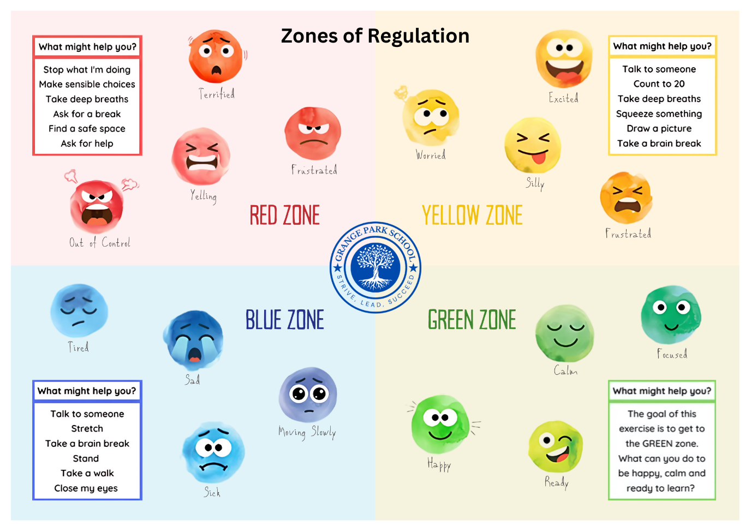
In classrooms, staff support children to identify which zone they are in and use tools or strategies to return to the green zone. These may include breathing techniques, movement breaks, sensory input, or short periods of reflection. Visual displays and check-in routines help normalise the language and make regulation part of everyday classroom practice. Pupils are taught that all zones are valid and our behaviour whilst in them is important.
In the playground, support staff and lunchtime supervisors are trained to use the same language and approach. Pupils are encouraged to label their feelings, seek help when needed, and apply the strategies they’ve practised in class.

The Zones of Regulation help children make sense of their emotions, reduce incidents of escalation, and empower them to take ownership of their behaviour. Over time, children build confidence and resilience — essential skills for learning, relationships and life beyond primary school.

- Restorative practice

At Grange Park School, restorative practice is central to how we build relationships, respond to behaviour, and promote pupil well-being. We believe that teaching pupils to reflect, repair and restore is not only a behaviour strategy, but a vital life skill.

Restorative practice focuses on repairing harm and rebuilding trust after behaviour incidents. It encourages accountability, empathy and personal growth. This approach supports our wider goal of helping pupils develop emotional literacy, conflict resolution skills and a deep understanding of how their actions affect others.

Restorative conversations take place after an incident once the child is calm, regulated, and ready to engage. These conversations are facilitated by staff and use a consistent structure, such as:
- What happened?
- What were you thinking and feeling at the time?
- Who was affected and how?
- What needs to be done to put things right?
- What could you do differently next time?

The process helps pupils recognise the consequences of their actions, express their feelings, and understand others’ perspectives. It also provides an opportunity for those harmed to be heard and supported.

Restorative practice is used alongside our other sanctions where appropriate, and is never a replacement for ensuring safety, boundaries and consistency. It is particularly effective in supporting pupils with social, emotional or communication needs, as it offers a structured, empathetic way of learning from behaviour.

In addition to addressing behaviour, restorative practice plays a key role in fostering pupil well-being. By encouraging open dialogue, emotional expression and problem-solving, pupils develop resilience, self-awareness and stronger peer relationships.

Over time, this approach contributes to a positive school climate where respect, kindness and reflection underpin how we treat one another — and where every child has the tools to grow socially and emotionally.

- Support provided in school
At Grange Park School, we recognise that behaviour is often a reflection of underlying needs. As such, we are committed to providing a proactive, inclusive and graduated response to support pupils who may struggle to meet behaviour expectations. We aim to identify barriers early and offer tailored interventions that promote well-being, emotional regulation and positive relationships.

Support is co-ordinated in collaboration with class teachers, the SENDCo, the Pastoral Officer, the behaviour lead, and where appropriate, parents, external agencies, and the pupil themselves. We also work in line with the graduated approach set out in the SEND Code of Practice, using the cycle of assess–plan–do–review to evaluate impact and adjust provision.

Pastoral and Behaviour Support

Pupils who require additional support with behaviour may receive:
- Daily or weekly check-ins with a trusted adult
- Weekly intervention groups
- Individual Behaviour Support Plans
- Zones of Regulation work
- Access to mentoring or emotional literacy support (ELSA)
- Time in a calm space to regulate
- Targeted group work focused on social skills, resilience or conflict resolution
- Regular communication with home and collaborative reviews

Where behaviour incidents become frequent or escalating, pupils may be referred to the SENDCo or pastoral team for further assessment and targeted intervention.

ABC Behaviour Charts

One of the tools we use to support pupils is the ABC Behaviour Chart, which helps staff and children understand the patterns and triggers behind specific behaviours.
ABC stands for:
- Antecedent – what happened before the behaviour?
- Behaviour – what was the behaviour?
- Consequence – what happened after?

By recording behaviour in this structured way, we can begin to identify patterns, such as sensory triggers, transitions, peer dynamics, or adult interactions that may influence behaviour. ABC charts are used for both diagnostic and reflective purposes, forming a key part of Behaviour Support Plans. Pupils are often involved in this process to help build awareness and ownership of their choices and needs.

ABC tracking informs future planning, environmental changes, and targeted interventions. It also enables meaningful conversations with families and external professionals when additional support is required.

- Use of reasonable force and restrictive intervention
Reasonable force refers to a range of interventions, including physical contact with pupils. Restrictive intervention refers to any action that restricts a pupil’s movement, liberty, or freedom to act independently, and may include reasonable force as well as non-physical interventions. All staff members may use reasonable force to prevent a pupil from:

- Causing harm to themselves or to others
- Damaging property
- Committing an offence
- Causing disorder

When reasonable force is used, this must always be:
- A last resort
- Applied using the least possible amount of force for the smallest amount of time
- Be used in a way that does not affect the safety and dignity of all involved
- Reported to parents and documented clearly
- In the pupil’s best interest and never as a form of punishment

When considering if reasonable force is needed, all members of staff must consider the risks and consider whether the pupil has a specific vulnerability including SEND, medical conditions or mental health needs. All members of staff are familiar with DFE guidance ‘Use of Reasonable Force - advice for school leaders, staff and governing bodies’.

- Searching, screening and confiscated items
At Grange Park School, the safety, welfare and dignity of all pupils and staff are paramount. In accordance with the DfE’s Searching, Screening and Confiscation: Advice for Schools (2022) (link), staff have the power to search, screen and confiscate items where necessary to maintain a safe and orderly environment.

Searching and screening are used proportionately, in line with our safeguarding and behaviour policies, and are always carried out with respect for the pupil’s rights and well-being.

Searching with Consent

School staff can search a pupil for any item with the pupil’s consent. Consent is not always required in writing, and staff can instruct a pupil to turn out their pockets or open a bag. Refusal to comply may be considered a breach of the school’s behaviour policy.

Searching Without Consent

The headteacher and authorised staff may search a pupil or their possessions without consent if there are reasonable grounds to suspect that the pupil has any of the following prohibited items:
- Knives or weapons
- Alcohol
- Illegal drugs
- Stolen items
- Tobacco, vapes or cigarette papers
- Fireworks
- Pornographic images
- Any article that has been or is likely to be used to commit an offence, cause personal injury or damage to property

Additionally, the school prohibits other items not suitable for a learning environment. These include:
- Mobile phones (where school policy prohibits their use during the day)
- Energy drinks or high-caffeine products
- Offensive materials (including hate-related or discriminatory symbols)
- Any item deemed to pose a risk to pupil well-being or school order

These items may be confiscated whether found during a search or not.

Searches without consent will always be conducted by two members of staff, including one of the same sex as the pupil (except in exceptional circumstances where there is risk of serious harm and no same-sex staff are available). Staff will explain the reason for the search, remain calm, and respect the pupil’s privacy and dignity.

Screening

School staff may require pupils to undergo screening by a walk-through or hand-held metal detector (arch). This may be used to ensure safety at specific times, such as after a serious incident or to prevent recurrence of known risks. Refusal to comply with screening is treated as a breach of the behaviour policy.

Confiscation

Staff have the authority to confiscate, retain or dispose of a pupil’s property if it is believed to be causing disruption, breaking school rules, or posing a risk. Confiscated items may be:
- Returned at the end of the day
- Held until collected by a parent or carer
- Disposed of or handed to the police, if illegal or dangerous

Staff are protected from liability for damage or loss provided they act lawfully and proportionately.
The school is not responsible for loss or theft of personal items that are brought to school against advice.

Safeguarding and Recording

All searches, screenings and confiscations are recorded, including the reason, outcome, and those present. Any search that results in concern for a pupil’s safety, well-being or potential harm will be reported to the Designated Safeguarding Lead and followed up in line with KCSIE (2024).
Pupils are informed of their rights and responsibilities regarding searches, and parents will be contacted where appropriate. Any concern involving prohibited or harmful items will be handled with sensitivity, care and professionalism.

15. Permanent exclusions
Aligned with DfE Suspension and Permanent Exclusion Guidance (2023)

At Grange Park School, we are committed to creating a safe, inclusive and respectful environment where all pupils can thrive. Permanent exclusion is a serious decision and is used only when absolutely necessary, either in response to a single serious breach of the behaviour policy or an accumulation of persistent incidents where previous interventions have not led to improvement.

A permanent exclusion may be considered for:
- Serious violence or physical assault against another pupil or staff member
- Possession of prohibited items, such as weapons or illegal drugs
- Significant harm to the safety or welfare of others
- Repeated disruptive behaviour that significantly affects the learning or well-being of others
- Persistent defiance, including refusal to follow reasonable instructions or uphold core behaviour expectations
- Incidents of hate-related, discriminatory, or targeted abuse
- Serious misuse of technology or social media where school reputation, pupil safety or well-being are compromised

Before making a decision to exclude, the headteacher will conduct a thorough investigation, ensuring the pupil has had an opportunity to share their account. The headteacher will also consider the context of the behaviour, the pupil’s individual needs, and whether reasonable adjustments have been made, particularly for pupils with SEND.

Permanent exclusion will only be applied when it is clear that allowing the pupil to remain in school would seriously harm the education, safety or welfare of others. The decision will always be lawful, reasonable, and proportionate, following the statutory process set out by the Department for Education.

Parents will be informed promptly, provided with written notification, and supported to understand their right to appeal. Where appropriate, the school will work with the local authority and other agencies to support the pupil’s transition to a new educational setting.

16. Working with parents
At Grange Park School, we believe that strong, trusting relationships between school and home are essential for promoting positive behaviour, emotional well-being and academic success. When schools and families work together, children are more likely to feel secure, supported and motivated to engage in their learning.

We are committed to fostering open and proactive communication with all parents and carers. Behaviour is most effectively managed when expectations are shared, consistent and reinforced both at school and at home. Our behaviour approach emphasises early intervention and partnership — not just at times of difficulty, but through regular engagement and celebration of positive behaviour.

Communication and Collaboration

We communicate with parents regularly in a variety of ways, including:
- Class Dojo messages
- Verbal feedback at drop-off or collection times
- Weekly learning updates from class teachers on Class Dojo
- Invitations to assemblies and celebration events
- Behaviour reports, check-ins or home–school diaries for individual pupils
- Prompt contact when concerns arise

Where behaviour difficulties become ongoing, staff will meet with parents to agree on a shared approach and to create a Behaviour Support Plan if needed. Parents are involved in reviewing these plans and are encouraged to contribute strategies that work well at home.
We value parental insight into children’s strengths, triggers and needs. By working together, we can identify underlying causes of behaviour and build consistency in how we respond to and support it.

Inclusion and Support

We recognise that every family’s circumstances are different. We aim to communicate in ways that are inclusive, accessible and sensitive. Where needed, we offer support through:
- Translation or interpretation services
- Pastoral or family support referrals
- Access to external agencies or parenting workshops
- Signposting to Early Help or local authority services
Our goal is to ensure that all families feel welcome and confident in engaging with the school, especially during challenging times.

Celebrating Success Together

We make a deliberate effort to share positive news with families — recognising effort, improvement, kindness and responsible choices. Celebrating these behaviours reinforces their value and strengthens the child’s motivation and self-esteem.
Through strong home–school links, we work collaboratively to help every child build positive relationships, develop emotional regulation, and succeed both socially and academically.

17. Monitoring the policy
At Grange Park School, we are committed to ensuring that our Behaviour Policy is implemented consistently, fairly, and effectively across the whole school. Monitoring the impact of this policy is essential to maintaining a safe, inclusive learning environment and supporting continuous improvement.

The senior leadership team (SLT) is responsible for regularly reviewing the implementation of the policy, ensuring that behaviour expectations are understood by all pupils and applied consistently by staff. This includes:
- Regular learning walks, behaviour observations and pupil voice interviews
- Reviewing records of behaviour incidents and interventions on our behaviour tracking system, CPOMS
- Analysing trends in exclusions, suspensions, incidents and support referrals
- Monitoring the use and impact of restorative practice, reasonable adjustments, and targeted support

Behaviour data is reviewed termly and shared with governors to ensure transparency and accountability. The governing body holds school leaders to account for ensuring the policy is equitable, inclusive and aligned with statutory guidance.

Feedback is also gathered from staff, pupils and parents to evaluate the effectiveness and clarity of the policy. Where necessary, training or additional guidance is provided to staff to ensure confidence in consistent application.

This policy is formally reviewed at least annually, or earlier if required by legislative change or as part of whole-school development planning. Revisions are made in consultation with key stakeholders, including governors, staff, pupils and parents.

By monitoring the behaviour policy carefully, we ensure it remains responsive, inclusive and effective in supporting all pupils to succeed.

Appendix 1 – Scripting example

Context: A child is talking to a friend while the teacher is giving instructions.
  - “I noticed you were chatting while I was giving instructions. What do you think might happen if you don’t hear them properly?”
  - “How can we help you focus so you don’t miss out?”
  - “What could you do differently next time?”

Context: A child pushes in front of others during playtime line-up.
  - “I saw you move ahead of others. How do you think that made your friends feel?”
  - “What’s a fair way to join the line?”
  - “What could you do now to make it right?”

Context: A child keeps wandering around the classroom instead of sitting.
  - “I noticed you were moving around a lot. What was making it hard to sit?”
  - “How does it affect others when you’re walking around?”
  - “What could help you stay focused in your place next time?”

Context: A child makes a negative comment about someone’s work.
  - “I heard your comment about your friend’s work. How do you think that made them feel?”
  - “What kind of words could you use to encourage instead?”
  - “How can you make things right with your friend now?”

