



Maths — No Problem!

Grange Park

Calculation

Policy

## Addition Calculation Policy



### Year 3

**Year Topic/Strand Representation Key Idea**

Year 3 Part – Part – Whole

*9 + 8 = 17*

*8 + 9 = 17*

**17**

**9**

**8**



*17 − 9 = 8*

*17 − 8 = 9*

***17 is the whole.***

***8 and 9 are the parts.***

This is a mathematical structure that underpins all addition situations. Numbers can be understood in terms of their parts; understanding that the parts are part of a larger collection.

Pupils develop an understanding of the parts and the whole within an equation.

Counting Number Line

|  |  |  |  |  |  |  |  |
| --- | --- | --- | --- | --- | --- | --- | --- |
| **Year 3 on Using a** *287 387 487*  *287 + 500 = 787* | *587* | *687* |  | *787* |  |  | Initially a 1-digit number is added to a 3-digit number, then this progresses to a number line shown with intervals of 1, then 10 and eventually to 100. |
|  |  |  |  | **h**  *2* | **t**  *8* | **o**  *7* | The use of base 10 blocks provides a representation of the place value of 3-digit numbers.  This representation is related to the formal written method but also encourages pupils to use their understanding of adding the same noun to add  3-digit numbers. For example, 200 + 500 can be |
| **Year 3 Base 10 Blocks** |  |  | *+* | *5* | *0* | *0* | understood as 2 hundreds + 5 hundreds. The sum |
|  |  |  |  | *7* | *8* | *7* | of these numbers is 700 or 7 hundreds. |

*100 more 100 more 100 more 100 more 100 more*

The use of the number line is further developed when counting starts from a given number, relying on pupils’ ability to locate and count from a given number, including starting from a 3-digit number.

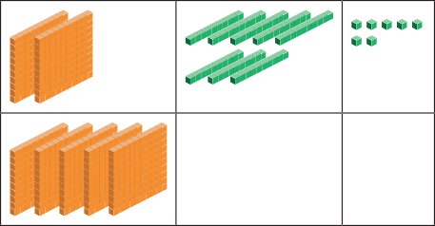

*287 + 500 = 787*



**287** *+ 500*

**87 200**

*787 fans watched the game in total. 200 + 500 = 700*

*87 + 700 = 787*

Progression is made by adding ones, then tens and finally hundreds before the addition of all 3 is undertaken.

An understanding of place value will support addition as well as subtraction, multiplication and division.

*413 + 582 =*

*Step 1 Add the ones.*

*3 ones + 2 ones = 5 ones*

|  |  |  |
| --- | --- | --- |
|  |  |  |
|  |  |  |

Year 3 Formal Written Method

*Step 2 Add the tens.*

*1 ten + 8 tens = 9 tens*



*Step 3 Add the hundreds.*

*4 hundreds + 5 hundreds = 9 hundreds*

|  |  |  |
| --- | --- | --- |
|  |  |  |
|  |  |
|  |  |

*413 + 582 = 995*

**h t o**

*4 1 3*

*+ 5 8 2*

*5*

**h t o**

*4 1 3*

*+ 5 8 2*

*9 5*

|  |  |  |  |
| --- | --- | --- | --- |
|  | **h** | **t** | **o** |
| *4* | *1* | *3* |
| *+* | *5* | *8* | *2* |
|  | *9* | *9* | *5* |

This procedural method progresses from the renaming of 10 ones into 1 ten to include the renaming of 10 tens to 1 hundred. The procedure remains unchanged from Year 2.

Pupils understand that at this stage, they start with the addition of the ones, then the tens, then finally the hundreds.

This method is supported with base 10 block representation. The formal written method is always accompanied by a written equation to ensure that the relationship between the representations is made.

*498 + 50 =*

***48***

Pupils are given the opportunity to further develop their number sense by using a ‘make 100’ strategy with numbers that are ‘near hundreds’.

Year 3 Adding by Making 100

*498*

2

*+ 50*

*= 500 + 48*

They use their part–whole understanding to rename a given number to make 100. For example, 498 + 50 can be renamed as 498 + 2 + 48.

Pupils add 2 to 498 to make 500, then add the remaining 48.

Year 3 Estimating

Pupils use their number sense to recognise numbers close to a hundred and how estimation can help accuracy in completing a precise calculation.

*Lulu*



***I had 593 points. 593 is about 600.***



***I had 695 points. 695 is about 700.***



***I had 498 points. 498 is about 500.***

*Sam*

*Hannah*

*600 + 50 = 650 700 + 70 = 770 500 + 50 = 550*

*1 5*

*6 6*

|  |  |  |  |  |  |
| --- | --- | --- | --- | --- | --- |
|  |  | | | | |
|  |  |  |  |  |  |

Year 3 Adding Fractions

*?*

*1 sixth and 5 sixths make 6 sixths.*

*1 5 6*

Pupils use their understanding of adding the same noun when adding fractions with the same denominator.

The adding of fractions uses equations and is supported through pictorial representation.

*6 + 6 = 6*

*= 1*

## Addition Calculation Policy



### Year 4

**Year Topic/Strand Representation Key Idea**

Year 4 Part – Part – Whole



***A number can be expressed as a sum of the values of its digits.***

*1436 = 1000 + 400 + 30 + 6*

This is a mathematical structure that underpins all addition situations. Numbers can be understood in terms of their parts; understanding that the parts are part of a larger collection. The bar model is used as a representation of a problem that can be related to a part–whole addition situation.

Pupils develop an understanding of the parts and the whole within an equation.

**1436**

**1000 400 30 6**

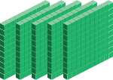

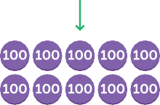**Year 4 Base 10 Blocks**



**10 10 10 10 10**

**10 10 10 10 10**

The use of base 10 blocks provides a representation of the place value of 3-digit numbers.

This representation is related to the formal written method but also encourages pupils to use their understanding of adding the same noun.

In Year 4, a transition between base 10 blocks and place–value counters takes place.

#### 

 



**10**

*10 ones = 1 ten 10 tens = 1 hundred 10 hundreds = 1 thousand*

*4506 + 3125 =*

*Step 1 Add the ones.*

*6 ones and 5 ones = 11 ones Rename the ones.*

*11 ones = 1 ten and 1 one*

Year 4

**Place–Value Counters**

*4 5 10 6*

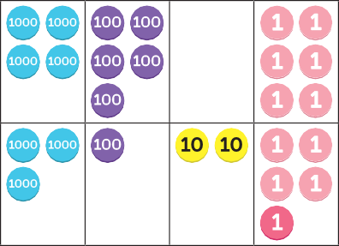*+ 3 1 2 5*

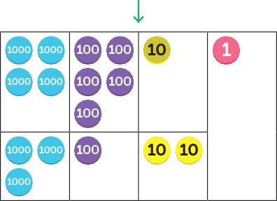*1*

Place–value counters are used to represent addition situations. This transition relies on pupils understanding the value of each counter without being able to count its physical attributes.

Pupils will have the opportunity to rename 10 counters of the same value to 1 counter with a value 10 times greater and vice versa. The idea of composing and decomposing at a rate of 10 should be well understood at this stage.

*4188 + 3245 =*

Pupils will have the opportunity to use a long and short version of this procedural method. In the long representation, the sum of adding each place is shown in its entirety before being added to find the final sum.

|  |  |  |  |  |  |  |  |
| --- | --- | --- | --- | --- | --- | --- | --- |
|  | |  | *4* | *1* | *8* | *8* |  |
| *+* | *3* | *2* | *4* | *5* |
|  |  |  | *1* | *3* | *Add the ones.* |
|  |  |  |  | *1* | *2* | *0* | *Add the tens.* |
|  | **Formal** |  |  | *3* | *0* | *0* | *Add the hundreds.* |
| **Year 4** | **Written** | *+* | *7* | *0* | *0* | *0* | *Add the thousands.* |
|  | **Method** |  | *7* | *4* | *3* | *3* |  |
|  |  |  | *2* | *6* | *1* | *2* |  |
|  |  | *+* | *4* | *2* | *6* | *4* |  |
|  |  |  | *6* | *8* | *7* | *6* |  |

In the short representation, the sum of each place is shown as part of the total sum and as a small

number added to an existing place when a ten of one place is made.

The procedure remains unchanged from Year 2.



Year 4 Estimating the Sum

*Start by estimating. 4188 ≈ 4200*

*3245 ≈ 3200*



***The answer will be about 7400.***

*4200 + 3200 = 7400*

Estimation is introduced as an approach to start a calculation. Estimation is a skill that helps develop number sense. Pupils are expected to be able to decide if an answer is reasonable. Beginning a calculation with estimation is developed during the addition chapter.

Year 4

**Making 10 and**

Making 100

*make 10*

*4072 + 8 =*

*4072 + 8 = 4070 + 10*

*4072 + 8 = 4080*

*make 100*

*97 + 5213 =*

*97 + 5213 = 100 + 5210*

*= 5310*

A mental method that involves renaming numbers to make 10 or 100 before finding the sum.

Pupils develop their number sense by recognising numbers close to a ten or close to a hundred and renaming a number in the equation to bring a number to the nearest 10 or nearest 100 without having to compensate the sum.

*Lulu used this method to find the sum of 3067 and 9.*



**1**



***I know adding 9 is 1 less than adding 10.***

*3067 + 10 = 3077*

Year 4

**Adding Using Compensation**

*3067 + 9 = 3076*

1. *less*

A mental method that uses a similar equation in which a number in the original calculation is shown to the nearest 10 or 100 before carrying out the

*Ravi used this method to find*



**2**

*the sum of 98 and 5262.*

*100 + 5262 = 5362*

calculation. This calculation is used to help find the

sum of the original equation.



***I know adding 98 is 2 less than adding 100.***

*98 + 5262 = 5360*

1. *less*

Year 4 Adding Fractions

|  |  |  |
| --- | --- | --- |
|  |  |  |

|  |  |  |
| --- | --- | --- |
|  |  |  |

|  |  |  |
| --- | --- | --- |
|  |  |  |

*1 + 1 = 2*

Pupils use their understanding of adding the same noun when adding fractions with the same

denominator. The adding of fractions uses equations and is supported through pictorial representation.

Pupils use their understanding of equivalence to ensure denominators are the same before carrying out the addition.

*3 3 3*

## Addition Calculation Policy



### Year 5

**Year Topic/Strand Representation Key Idea**

*32 541 + 24 000 =*

#### 



***Count on 4000 in 1000s.***

Year 5

**Counting**

on Using Place–Value Counters

Pupils use place–value counters to support counting on in thousands to find the sum.

#### 



***32541, 33541,***

***34541, 35541,***

***36541***

Year 5

**Counting on Using**

Number Lines

*Count on 24 000 from 32 541.*

*+ 1000 + 1000 + 1000 + 1000*

*32541 33541 34541 35541 36541*

*32 541 + 4000 = 36 541*

*+ 10000 + 10000*

*24 000*

#### 

*20 000 4000*

Pupils count in thousands and ten thousands, using a number line to show this counting on method.

*36541 46541 56541*

*36 541 + 20 000 = 56 541*

*32 541 + 24 000 = 56 541*

Year 5

**Formal Written Method**

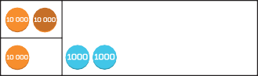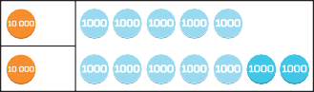*1*

*1 5 0 0 0*

*+ 1 7 0 0 0*

*3 2 0 0 0*

5 thousands + 7 thousands = 12 thousands

***12 thousands = 1 ten thousand + 2 thousands***



Place–value counters are used to represent the formal written method.

The procedure remains unchanged from Year 2.

*15 000 + 17 000 = 32 000*

*Add 1 , 1 and 3 .*

Year 5 Adding Fractions

*2 6 12*

|  |  |  |  |  |  |
| --- | --- | --- | --- | --- | --- |
|  |  |  |  |  |  |

*1 1 3*

*2 6 12*

Pupils use their understanding of adding the same noun when adding fractions with the same

denominator. The adding of fractions uses equations and is supported through pictorial representation.

Pupils use their understanding of equivalence to

*1 + 1 + 3 = 6 + 2 + 3*

ensure denominators are the same before carrying

*2 6 12*

*12 12 12*

*11*

*=*

*12*

out the addition.

Year 5

**Adding Decimals**



***0.1 is 1 tenth.***

*pancakes sweetcorn fritters*

*0.1 + 0.2 = 0.3*

* 1. *kg*
  2. *kg*

Pupils use their understanding of adding the same nouns when adding tenths. Tenths are represented using bar models, written words and equations.

Year 5

**Adding Decimals Using the Formal Written Method**



***1 tenth and 2 tenths make tenths.***

*£ 11 . 8 0*

*+ £ 0 . 7 0*

*£ 2 . 5 0*

The procedure for adding decimals using a formal written method is the same as when adding whole numbers, but attention needs to be given to the decimal point. The decimal point does not represent a place but separates the whole from the fractional part of a number. Careful alignment is needed when adding decimal numbers using a formal written method.

## Addition Calculation Policy



### Year 6

**Year Topic/Strand Representation Key Idea**

Year 6

**Addition within Order of Operations**

*First, carry out all the operations in ( ).*

*Next, perform all the multiplication and division. Then, calculate all the addition and subtraction.*

*Calculate.*

*(a) (1 + 3) × 5 – 7 =*

*(b) 1 + (3 × 5) – 7 =*

*(c) (1 + 3) × (7 – 5) =*

Pupils utilise the previous addition skills within mixed operation equations. Addition is carried out after multiplication and division. If only addition and subtraction are present in an equation, pupils work from left to right.

*1 = 3 1 = 2*

*1 2*

|  |  |  |  |  |  |
| --- | --- | --- | --- | --- | --- |
|  |  |  |  |  |  |

Year 6 Adding *1*

*+*

|  |  |  |  |  |  |
| --- | --- | --- | --- | --- | --- |
|  |  |  |  |  |  |

*2 6 3 6*

|  |  |  |  |  |  |
| --- | --- | --- | --- | --- | --- |
|  |  |  |  |  |  |

Pupils use their understanding of adding the same noun when adding fractions with the same and different denominators.

Fractions

*3 ?*

*1 1 5*

*+ =*

*2 3 6*

Pupils use their understanding of equivalence to

ensure the nouns and the denominators are the same before the calculation is completed.

Year 6 Adding Decimals

*£ 13 . 9 0*

*+ £ 2 . 5 0*

*£ 6 . 4 0*

Pupils use their understanding of adding the same nouns when adding decimal numbers. They use place–value knowledge and composing and

decomposing at a rate of 10 when adding decimals.

The procedure remains the same as adding whole numbers.



**Year Topic/Strand Representation Key Idea**

Year 6 Bar Models

*1 2*

*dogs*

*3*

*4*

*cats*



*240*

*dogs*

*cats*

*6 units*

*1 2*

|  |  |  |  |  |  |
| --- | --- | --- | --- | --- | --- |
|  |  |  |  |  |  |

*240*

Pupils are expected to utilise previously learned addition skills within increasingly complex situations. The procedure of addition is often at a level previously learned in isolation but the skill being developed is identifying when to use addition within a problem.

*There are 6 + 4 units altogether. 10 units = 240*

*1 unit = 24*

*4 units*

## Subtraction Calculation Policy



### Year 3

**Year Topic/Strand Representation Key Idea**

Year 3 Part–Part– Whole

*9 + 8 = 17*

*8 + 9 = 17*

**17**

**9**

**8**



*17 − 9 = 8*

*17 − 8 = 9*

***17 is the whole.***

***8 and 9 are the parts.***

This is a mathematical structure that underpins subtraction situations. Numbers can be understood in terms of their parts; understanding that the parts are part of a larger collection.

Pupils develop an understanding of the parts and the whole within an equation.

Year 3

**Counting Back Using a Number Line**

*100 less 100 less 100 less 100 less 100 less 100 less*

*196 296 396 496 596 696 796*

*796 – 600 = 196*

The use of the number line is further developed when counting back starts from a given number, relying on pupils’ ability to locate and count back from a given number, including starting from a

3-digit number.

Initially a 1-digit number is subtracted from a 3-digit number, then this progresses to a number line shown with intervals of 1, then 10 and then progressing to 100.

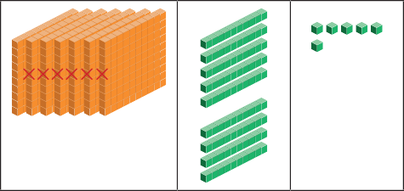

**h t o**

*7 9 6*

*− 6 0 0*

*1 9 6*

*796 – 600 = 196*

*There were 196 people left at the airport.*

**796** *−*

*600*

**96**

**700**

*700 − 600 = 100*

*96 + 100 = 196*

Year 3 Base 10 Blocks

The use of base 10 blocks provides a representation of the place value of 3-digit numbers. This representation is related to the formal written method but also encourages pupils to use their understanding of subtracting the same noun to subtract from 3-digit numbers. For example, 700 – 400 can be understood as 7 hundreds – 4 hundreds. The difference between these numbers is 300 or 3 hundreds. Progression is made by subtracting ones, then tens and finally hundreds before the subtraction of all 3 places is undertaken. An understanding

of place value will support subtraction as well as addition, multiplication and division.

*507 – 143 =*



**507**

**400 100 7**

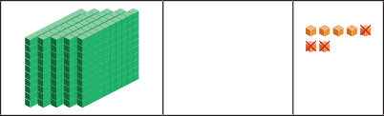*Step 1 Subtract the ones.*

*7 ones – 3 ones = 4 ones*

**h t o**

*5 0 7*

*– 1 4 3*

*4*

Year 3 Formal Written Method

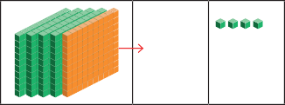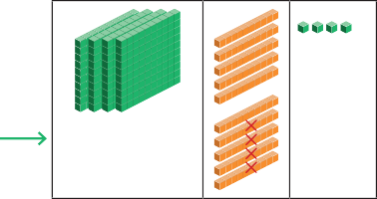

*Step 2 Rename 1 hundred as 10 tens.*

*Subtract the tens.*

*10 tens – 4 tens = 6 tens* **h t o**

This procedural method progresses from the renaming of 10 ones into 1 ten to include the renaming of 10 tens to 1 hundred when necessary. The procedure itself remains unchanged from Year 2.

Pupils understand that at this stage, they start with the subtraction of the ones, then the tens, then finally the hundreds.

This method is supported with base 10 block representation. The formal written method is

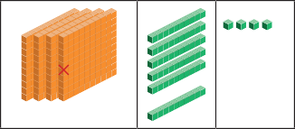*Step 3 Subtract the hundreds.*

*4 10*

*5 0 7*

*– 1 4 3*

*6 4*

**h t o**

always accompanied by a written equation to ensure that the relationship between the representations are made.

|  |  |  |  |  |
| --- | --- | --- | --- | --- |
|  |  | *4*  *5* | *10*  *0* | *7* |
| *–* | *1* | *4* | *3* |
| *4 hundreds – 1 hundred = 3 hundreds* |  | *3* | *6* | *4* |
| *507 – 143 = 364* |  |  |  |  |

Year 3 Inverse Operation

*748 – 425 =*

*Step 1 Subtract the ones.*

*8 ones – 5 ones = 3 ones*

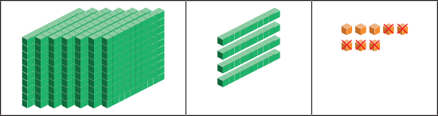

h t o

*7 4 8*

*– 4 2 5*

*3*

Pupils should understand that subtraction is the inverse operation of addition. They are encouraged to check completed subtraction calculations using addition.

*Step 2 Subtract the tens.*

*4 tens – 2 tens = 2 tens*

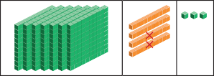

**h t o**

*7 4 8*

*– 4 2 5*

*2 3*

Year 3

**Difference Using a Bar Model**

*Step 3 Subtract the hundreds.*

*7 hundreds – 4 hundreds = 3 hundreds*

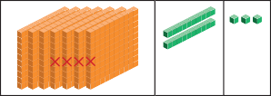

*748 – 425 = 323*

*323 tomatoes are left.*



***Check your answer using addition. 323 + 425 = 748***

**h t o**

*7 4 8*

*– 4 2 5*

*3 2 3*

Pupils are required to find the difference in a comparison problem when represented by a bar model. To find the difference, the known part is subtracted from the quantity it is being compared to. The comparison model reinforces the understanding of difference in subtraction.

## Subtraction Calculation Policy



### Year 4

**Year Topic/Strand Representation Key Idea**

Year 4 Part–Part– Whole

*4 0 0*

*– 1 0 0*

*3 0 0*

*432*

*2 0*

*– 1 0*

*1 0*

*1 2*

*– 9*

*3*

This is a mathematical structure that underpins subtraction situations. Numbers can be understood in terms of their parts; understanding that the parts are part of a larger collection.

Pupils develop an understanding of the parts and the whole within an equation.

*What is the difference between 432 and 119?*



***There are not enough ones. Rename 1 ten as 10 ones.***

Year 4

**Place–Value Counters**

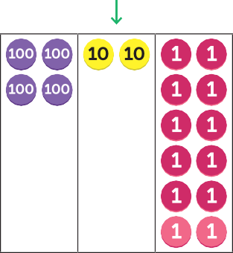*4 0 0*

*– 1 0 0*

*3 0 0*

*432*

*2 0*

*– 1 0*

*1 0*

*1 2*

*– 9*

*3*

Place–value counters are used to represent subtraction situations. This transition from base 10 blocks relies on pupils understanding the value of each counter without being able to count its physical attributes.

Pupils will have the opportunity to rename 1 counter to 10 counters with a value 10 times smaller in order to carry out a formal written method. The idea of decomposing at a rate of 10 should be well understood at this stage.

*5*

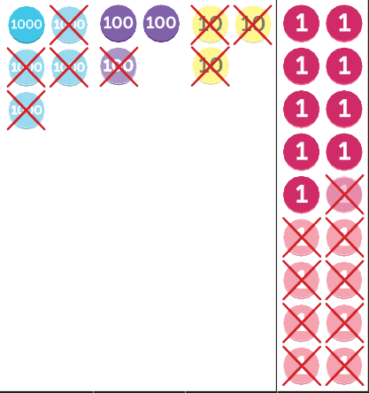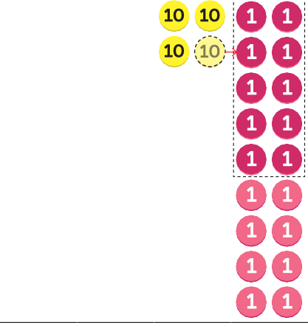

***Rename 1 ten***

***to 10 ones.***

*3*

*34 188*

*1 3 9*

*− 4*

Year 4 Formal Written Method



***Now there are enough ones to subtract.***

*5*

*− 4*

*1*

*3*

*34 188*

*1 3 9*

*2 0 9*

Pupils will use the formal written method initially without renaming, and then move to subtraction that requires renaming.

The procedure remains the same as learned in Year 3 but the numbers increase to include 4-digit numbers being subtracted from 4-digit numbers.

*5348*

*5 3 34 188*

Year 4

**Using Addition to Check Subtraction**

*5000 300 30 18*

*Step 1 Subtract the ones.*

*18 ones – 9 ones = 9 ones*

*Step 2 Subtract the tens.*

*3 tens – 3 tens = 0 tens*

*Step 3 Subtract the hundreds.*



***Check.***

***1 2 0 9***

***+ 4 1 3 9***

***5 3 4 8***

*− 4 1 3 9*

*1 2 0 9*

Pupils are encouraged to check subtraction calculations by adding the parts (the subtrahend and the difference) to ensure the sum is equal to the whole (the minuend).

*3 hundreds – 1 hundred = 2 hundreds*

*Step 4 Subtract the thousands.*

*5 thousands – 4 thousands = 1 thousand*

*5348 – 4139 = 1209*

Year 4 Mental Methods

*3002 – 198 = 2804*

**3002**

**2802 200**

*3002 – 198 = 2802 + 2*



***200 – 198 = 2***

Mental subtraction methods include partitioning the minuend to simplify the subtraction calculation. The approach shown is supported by an understanding of number bonds to 10 and to 100.

Year 4

**Subtracting Fractions**

|  |  |  |  |  |  |  |  |  |  |
| --- | --- | --- | --- | --- | --- | --- | --- | --- | --- |
|  |  |  |  |  |  |  |  |  |  |

|  |  |  |  |  |  |  |  |  |  |
| --- | --- | --- | --- | --- | --- | --- | --- | --- | --- |
|  |  |  |  |  |  |  |  |  |  |

*7 10 7*

*3 – = 2 –*

*10 10 10*

*3*

*2 1 10*

*= 2*

Pupils use their understanding of subtracting the same nouns when subtracting fractions with the same denominator.

The subtraction of fractions or finding the difference between fractions is supported through pictorial representation.

Pupils use their understanding of equivalence to ensure denominators are the same before carrying out the subtractions.



***1 = 10***

***10***

## Subtraction Calculation Policy



### Year 5

**Year Topic/Strand Representation Key Idea**

*Subtract 3000 from 650 452.*

*Start at 650 452. Count back in 1000s.*



***How can I count back from 50000?***



***You could exchange***

***for ten .***

Year 5

**Counting Back Using Place–Value Counters**

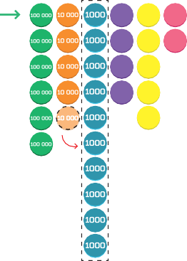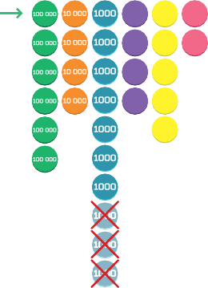Pupils use place–value counters to support counting back in thousands to find the difference.

|  |  |  |  |  |  |  |  |  |
| --- | --- | --- | --- | --- | --- | --- | --- | --- |
| *650452* |  |  | *650452* |  |  | *647 452* |  | |
| **100** | **10** | **1** | **100** | **10** | **1** | **100** | **10** | **1** |
| **100** | **10** | **1** | **100** | **10** | **1** | **100** | **10** | **1** |
| **100** | **10** |  | **100** | **10** |  | **100** | **10** |  |
| **100** | **10** |  | **100** | **10** |  | **100** | **10** |  |
|  | **10** |  |  | **10** |  |  | **10** |  |

*650 452 − 3000 =*

Year 5

**Counting Back Using**

*Count back 30000 from 153 672.*

*10 thousand less*

Pupils count back in thousands and ten thousands, using a number line to show this counting back

Number Lines

*123672 133672 143672 153672*

*153 672 – 30000 =*

method.

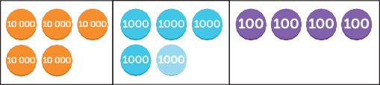*55 400 – 13 700 =*

Year 5

**Formal Written Method**

*Rename 1 thousand as 10 hundreds.*

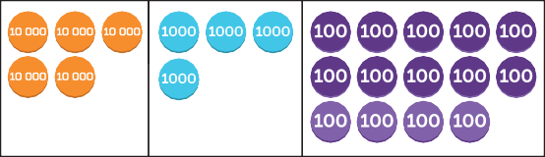

*Subtract 7 hundreds from 14 hundreds.*

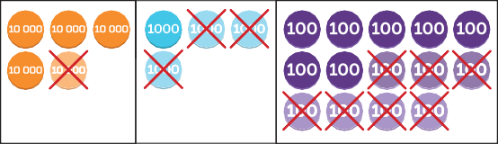

*4 14*

*5 5 4 0 0*

*– 1 3 7 0 0*

*7 0 0*

*Subtract the thousands. Subtract the ten thousands.*

Place–value counters are used to represent the formal written method. The procedure to subtract using numbers up to 6-digits using the formal written method remains the same as when it was first introduced.

Pupils begin at the least value place and work to the left through the places to find the difference.

Renaming takes place when a calculation in a place cannot be done. Again, this procedure is the same as when this was first learned and requires the renaming of the minuend.

The renaming of the minuend is also represented using a number bond, providing the foundation for mental methods that require renaming.

*4 14*

*5 5 4 0 0*

*– 1 3 7 0 0*

*1 7 0 0*

*4 14*

*5 5 4 0 0*

*– 1 3 7 0 0*

*4 1 7 0 0*

Year 5

**Checking by Using Estimation**

and Addition

*75 241 – 34 658 = 40 583*

*4 0 5 8 3*



***I checked my answer using addition.***

*+ 3 4 6 5 8*

*7 5 2 4 1*

*75 241 – 34 658 ≈ 75 000 – 35 000*



***I checked my answer using estimation.***

*= 40 000*

Pupils are encouraged to check the reasonableness of their answers by initially finding an estimated difference.

When using estimation to check, pupils initially round to the nearest thousand before calculation.

When using addition to check the difference, pupils add the difference and the subtrahend to check it is equal to the minuend.

Year 5 Subtracting Fractions

*1 – 1 = 6 – 1*

*5*



*=*

*6 6 6*

|  |  |  |  |  |  |
| --- | --- | --- | --- | --- | --- |
|  |  |  |  |  |  |

*6*

*5 5 10 5*

*– = –*

|  |  |  |  |  |  |  |  |  |  |  |  |
| --- | --- | --- | --- | --- | --- | --- | --- | --- | --- | --- | --- |
|  |  |  |  |  |  |  |  |  |  |  |  |

*6 12 12 12*

*5*

*=*

*12*

5 10

***6 12***

***=***

Pupils use their understanding of subtracting the same nouns when subtracting fractions with the same denominator. The subtraction of fractions or finding the difference between fractions is supported through pictorial representation. Pupils use their understanding of equivalence to ensure

denominators are the same before carrying out the subtractions.

Year 5 Subtracting Decimals

*Find the difference between 0.7 kg and 0.3 kg.*

*0.7 kg*

|  |  |  |  |  |  |  |
| --- | --- | --- | --- | --- | --- | --- |
|  | | | | | | |
|  |  |  |  |  |  |  |

* 1. *kg ?*

*0.7 – 0.3 = 0.4*

Pupils use their understanding of subtracting the same nouns when subtracting tenths. Tenths are represented using bar models, written words and equations.

*Find the difference between £3.40 and £2.50.*



*2 14*

*.*

*£ 3 4 0*

The same procedure for subtracting decimals using

Year 5

**Subtracting Decimals Using the Formal Written**

*− £ 2 . 5 0*

a formal written method is the same as when subtracting whole numbers but attention needs to be given to the decimal point. The decimal point does not represent a place but separates the whole from

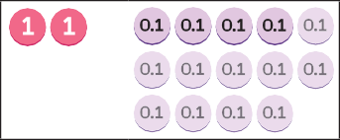Method

*2 14*

*£ 3 4 0*

*.*

the fractional part of a number. Careful alignment is

needed when subtracting decimal numbers using a

*− £ 2 . 5 0*

*£ 0 . 9 0*



*3.4*

***1 – 0.6 =***

***1 = 10 tenths***

***0.6 = 6 tenths***

formal written method.

Year 5

*4 =*

Subtracting Decimals Using Equivalence



*− 0.6*

**1**



**3**

Pupils use their understanding of equivalence to subtract a decimal from a whole number. For

example, when calculating 4 – 0.6 we can rename 4 as 40 tenths, so the calculation becomes 40 tenths

– 6 tenths. Once the nouns are the same, the subtraction can be carried out. 40 tenths – 6 tenths = 34 tenths = 3.4

### Year 6

**Year Topic/Strand Representation Key Idea**

*First, carry out all the operations in ( ).*

*Next, perform all the multiplication and division. Then, calculate all the addition and subtraction.*

Year 6



***Follow the order***

***of operations. Multiply, then subtract.***



***First, do the subtraction in the ( ).***

***Then multiply.***

**Subtraction within Order of Operations**

*15 − 4 × 3 = 15 − 12*

*= 3*

*(15 − 4) × 3 = 11 × 3*

*= 33*

Pupils utilise the previous subtraction skills within mixed operation equations. Subtraction is carried out after multiplication and division. If only addition and subtraction are present in an equation, pupils work from left to right.

Year 6 Bar Models

*£20*



*1 unit*

*= £40 – £20*

*= £20*

Pupils are expected to utilise previously learned subtraction skills within increasingly complex situations. The procedure of subtraction is often at a level previously learned in isolation but the skill being developed is identifying when to use subtraction within a problem.



## Multiplication Calculation Policy

### Year 3



**Year Topic/Strand Representation Key Idea**

Year 3

**Counting in 3s, 4s and 8s**

*3 6 9 12 15 18 21 24 27 30*

*33 36*

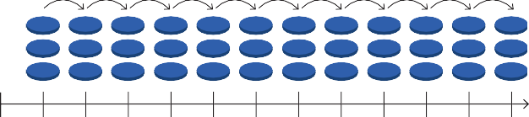When a pupil knows that the size of a group is 3, 4 and 8 and the group size remains consistent, they can count in multiples of 3, 4 and 8 to find the product. Counting in multiples is supported by

*0 3 6 9 12 15 18 21 24 27*

*30 33 36*

representation on a number line.



Year 3 Equal Groups

Multiplication by 3, 4 and 8 is shown initially using equal groups. Specific language is used to support these examples, in this case ‘4 groups of 3’, and this is immediately followed by the equation 4 × 3. This forms the basis of using known facts to find unknown facts.



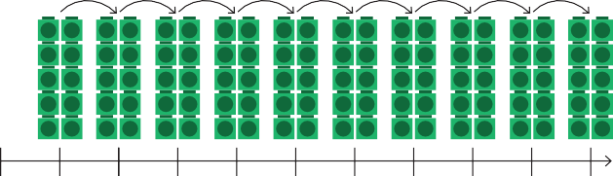*8 16 24 32 40 48 56 64 72 80*



Year 3 Number Line

*0 8 16*

*24 32*

*40 48*

*56 64*

*72 80*

Counting in multiples is shown on a number line. Multiples of 3, 4 and 8 are used as the intervals on a number line to support skip counting using these multiples.



Year 3

**Year 3**

Associated Facts

**Number Patterns**



*0*

*8*

*16*

*32*

Once the understanding of multiplication as the adding of equal groups is secure, this knowledge can be used to find unknown facts. For example, if a pupil knows 5 × 3 as 5 groups of 3, they can understand

that 6 × 3 is simply 1 more group of 3. So, 6 × 3 = 15

+ 3; 4 × 3 is seen as 1 group fewer than 5 × 3; 4 × 3

= 15 – 3.

This structure is used in all multiplication tables.

Pupils count in multiples of 3, 4 or 8 to identify missing multiples in a sequence. This reinforces the products found within the 3, 4 and 8 times tables.



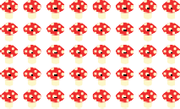*There are 5 rows of 8 mushrooms. 5 × 8 = 40*



***4 × 3 = 12***

***5 × 3 = 12 + 3***

***= 15***

Year 3 Commutativity

*There are 8 rows of 5 mushrooms. 8 × 5 = 40*

The representation of multiplication as an array is used to further develop the understanding of

commutativity. Having first understood multiplication as [ ] groups of [ ], pupils develop an understanding that 5 × 3 can also be read as 5 multiplied 3 times.

Pupils should have a firm understanding that the order the factors are multiplied in does not change the product.

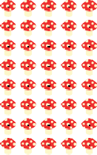*There are 40 mushrooms.*



***5 × 8 is the same***

***as 8 × 5.***



Year 3 Fact Families

*12 ÷ 3 = 4*

*4 × 3 = 12*

*12*

|  |  |  |
| --- | --- | --- |
|  | | |
| *4* | *4* | *4* |

The relationship between multiplication and division is shown using fact families. The product is a result of multiplying factors and dividing the product by a factor will equal the factor used during multiplication.



***I can see 6 hens.***



***There are twice as many hens in the red hen house.***

Year 3

**Multiplication Using**

Bar Models

*How many hens are in the red hen house?*

*6*



***There are 6 hens outside.***

*6 6*



***2 × 6 = 12***

Bar models are used in multiplicative comparison problems. Pupils use multiplication skills to determine quantities in comparison to another quantity.

Language such as ‘twice as many’, ‘three times as many’ and so on is developed in relation to multiplicative comparison problems.

*There are 12 hens in the red hen house.*

Year 3 Base 10 Blocks

*Multiply 2 tens by 4.*

   

*4 × 2 tens = 8 tens*

*4 × 20 = 80*

Base 10 blocks are used to support the understanding of multiplication of 2-digit numbers. Language and understanding is developed through the representation of 3 × 20 as 3 × 2 tens = 6 tens.

Pupils use known multiplication tables to 10 together with the place–value names of the digits being used to carry out the multiplication.

Year 3 Number Bonds

*12 × 3*



***8 tens = 80***

#### 

**10**



**2**

*10 × 3 2 × 3*

*= 30 = 6*

Number bonds are used to show numbers partitioned into tens and ones before being multiplied. The examples being used move from a number bond relating to an equation to an equation and the formal written method.

Year 3

*4 ones*

**Formal Written Method**

*Step 1 Multiply the ones.*

*6 ones × 4 = 24 ones*

*24 ones = 2 tens + 4 ones*

*Step 2 Multiply the tens.*

*3 tens × 4 = 12 tens*

*12 tens + 2 tens = 14 tens*

*36 × 4 = 144*

*23 6*

*× 4*

*2 tens*

*4*

h t o

*23 6*

*× 4*

*1 4 4*

This method is used to multiply a 2-digit number by a 1-digit number. Initially, the method shows the product of the multiplication of the ones, then the product of the multiplication of the tens, before adding the products to find the total. This method

progresses to include renaming and finally moves to a shortened form of the written method. The method is finally shown as a version of the formal written method, in which the product of the multiplication

of each place is shown as a single product, with any renaming added above each place in the multiplication.

## Multiplication Calculation Policy



### Year 4

**Year Topic/Strand Representation Key Idea**

Year 4 Counting in 6s, 7s and 9s

*Count on in sixes.* When pupils know that the size of a group is 6, 7 and 9 and the group size remains consistent, they can count in multiples of 6, 7 and 9 to find the product.

Counting in multiples is supported by representation on a number line using intervals of 6, 7 and 9.



|  |  |  |  |  |  |  |  |  |  |
| --- | --- | --- | --- | --- | --- | --- | --- | --- | --- |
| ***1*** | ***2*** | ***3*** | ***4*** | ***5*** | ***6*** | ***7*** | ***8*** | ***9*** | ***10*** |
| ***11*** | ***12*** | ***13*** | ***14*** | ***15*** | ***16*** | ***17*** | ***18*** | ***19*** | ***20*** |
| ***21*** | ***22*** | ***23*** | ***24*** | ***25*** | ***26*** | ***27*** | ***28*** | ***29*** | ***30*** |

Year 4 Equal Groups

*4 boxes of 6*

*4 × 6 = 24*

Multiplication by 6, 7 and 9 is shown initially using equal groups. Specific language is used to support these examples, in this case ‘4 groups of 6’, and this is immediately followed by the equation 4 × 6. This forms the basis of using known facts to find unknown facts.

Year 4 Number Line

Counting in multiples is shown on a number line. Multiples of 6, 7 and 9 are used as the intervals on a number line to support skip counting using these multiples. A growing pattern in multiples of 6, 7 and 9 is also shown to support pupils’ understanding.

*0 6 12 18 24 30 36 42 48 54 60 66 72*



Year 4

**Multiplying by 11 and 12 Using Associated Facts**

*10 + 10 + 10 = 30 1 + 1 + 1 = 3*

Learning to multiply by 11 and 12 is supported by partitioning 11 and 12 and using the 10 times

table as the basis for initial understanding, building towards immediate recall.



Year 4 Fact Families

  

*30 ÷ 6 = 5*

*6 × 5 = 30*

Fact families are used in the introduction of division, represented using arrays to show the relationship between factors and a product. Pupils relate 6



***3 × 10 = 30***

***3 × 1 = 3***

***3 × 11 = 30 + 3 = 33***

× 11 = 66 to 66 ÷ 6 = 11. They understand that multiplication can be used in division calculations.



Year 4 Multiplying

**by 0 and 1**

*3 pots of 1 ruler*

*3 × 1 = 3*

*3 empty pots*

*3 × 0 = 0*

Pupils initially use their understanding of ‘groups of’ to understand multiplying by zero. For example, 0 × 4 is read as ‘There are zero groups of 4’.

Pupils’ understanding then moves to read 0 × 4 as zero multiplied 4 times. The language is an extension of what they have already learned about multiplication.

|  |  |  |  |
| --- | --- | --- | --- |
|  |  |  |  |
|  |  |  |  |
|  |  |  |  |

Year 4 Commutativity

*3 × 4 4 × 3*

*3 × 4 = 4 × 3*

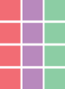

*3 × 4 is equal to 4 × 3.*

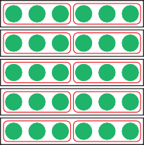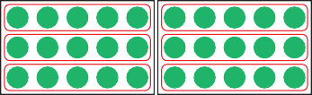*5 × 2 × 3 = 2 × 3 × 5 =*

Arrays are used to support the understanding of commutativity. Pupils learn the pattern of a × b = b

× a. Regardless of the order in which the factors are multiplied, the product remains the same.

The commutative property is further developed through the multiplication of 3 numbers. 3 factors are multiplied in different orders and the product remains the same.

Year 4 Multiplying

**Multiples of 10**

*30 is equal to 3 tens.*

*5 × 3 = 15*

*5 × 3 tens = 15 tens*

*= 150*

|  |  |  |
| --- | --- | --- |
| **10** | **10** | **10** |
| **10** | **10** | **10** |
| **10** | **10** | **10** |
| **10** | **10** | **10** |
| **10** | **10** | **10** |

*5 × 30 = 150*

Pupils learn to scale a product by a factor of 10 when multiplying a multiple of 10. For example, we know 3

× 4 = 12, therefore the product of 30 × 4 is 10 times

greater: 30 × 4 = 120.

Naming the place value of the digit supports this approach and pupils relate a known fact to

multiplying multiples of 10. For example, we can read 30 × 4 as 3 tens × 4. So, 3 tens × 4 = 12 tens or 120.

We would expect pupils to generalise and see that 30 × 4 = 3 × 4 × 10. While this isn’t formalised, this forms the basis of the distributive property of multiplication.

Year 4

**Formal Written Method**

*10 × 4 = 40*

|  |  |  |  |  |  |  |  |  |
| --- | --- | --- | --- | --- | --- | --- | --- | --- |
|  | *2* | *1* | *8* |  | | | | |
| *×* |  |  | *4* |
|  |  | *3* | *2* | *8 × 4 =* | | | | *32* |
|  |  | *4* | *0* |  | | | |  |
| *+* | *8* | *0* | *0* |  |  |  | *200 × 4 = 800* | |
|  | *8* | *7* | *2* |  |  |  | *218 × 4 = 872* | |

Pupils use formal written methods, short and long, to multiply a 2-digit number by a 1-digit number.

Initially the long method is used, showing the product of the multiplication of the ones, tens and hundreds, before adding the products to find the total. Pupils are shown the corresponding short formal written method so can make the links between the two procedures. Multiplication then moves from a 2-digit number by a 1-digit number to a 3-digit number by

a 1-digit number. Pupils should be aware that even though the number of digits in one number increases, the procedure remains the same.

## Multiplication Calculation Policy



### Year 5

**Year Topic/Strand Representation Key Idea**

1. *row of 8 stamps.*



*1 × 8 = 8*

1. *rows of 8 stamps.*



*2 × 8 = 16*

1. *rows of 8 stamps.*

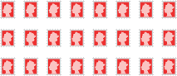

*3 × 8 = 24*

Year 5 Multiples

1. *rows of 8 stamps.*

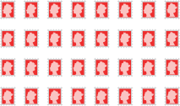

*4 × 8 = 32*

Finding multiples is initially related to skip counting. Pupils develop an understanding that counting in 2s produces a series of multiples that are also a product when 2 is a factor. They develop an understanding that the product is the multiple of two numbers.

1. *rows of 8 stamps.*



***A multiple is a number you get when you multiply one number by another number.***

***8, 16, 24, 32 and 40***

***are multiples of 8.***



*5 × 8 = 40*

The product of 5 and 8 is 40.

*Sam has 40 stamps altogether.*

***40 is a multiple of 5. 40 is also a multiple of 8.***

Year 5 Finding Factors

|  |  |  |  |  |  |  |  |  |  |  |  |
| --- | --- | --- | --- | --- | --- | --- | --- | --- | --- | --- | --- |
|  |  |  |  |  |  |  |  |  |  |  |  |
|  |  |  |  |  |  |  |  |  |  |  |  |



*2 rows of 12 tiles*

*2 × 12 = 24*

***2 and 12 are factors of 24.***

***Factors are the numbers we multiply together to make another number. 2 and 12 are factors of 24 because 2 × 12 = 24.***



*This is a rectangle.*

Pupils have already been working with factors for a significant amount of time but the term ‘factors’ is introduced in Year 5. The structure for introducing

factors uses rectangular arrangements and identifies the number of rows and number of items in each row.

Pupils’ understanding of factors is further developed when looking at common factors. They learn that different numbers can share some of the same factors. Pupils may go on to generalise about common factors. For example, all integers that end in 0 or 5 have 5 as a common factor.

Year 5

**Prime Numbers**

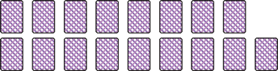

*These are not rectangles.*

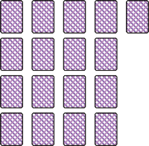*There is only one way to arrange 17 cards. 17 = 1 × 17*

*17 only has two factors, 1 and itself. 17 is a prime number.*

Following on from finding factors, pupils use rectangular arrangements to identify a pattern presented by prime numbers. Pupils find that prime numbers can only be arranged in a single rectangular pattern. This leads them to see that certain numbers only have two factors. These numbers, integers greater than 1, are called prime numbers.

 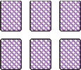

*6 = 1 × 6 6 = 2 × 3*



Year 5 Composite Numbers

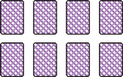*8 = 1 × 8 8 = 2 × 4*

Once pupils have a sound understanding of multiples, factors and prime numbers, the term ‘composite numbers’ is used to describe integers, greater than 1, that have more than two factors.

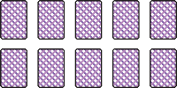*10 = 1 × 10 10 = 2 × 5*

*2 is the only even prime number.*

*All other multiples of 2 have more than two factors.*

Year 5

**Square and Cube Numbers**

1. *row of 1*

*1 × 1 = 12*



***Holly would need 9 square tiles to make a larger square.***

*= 1*



***Sam would need 27 cubes to make a larger cube.***

*1*

*1 1*

*1 × 1 × 1 = 13*

*= 1*

1. *rows of 2*

*2 × 2 = 22*

*= 4*

*2*



*2*

*2*

*2 × 2 × 2 = 23*

*= 8*

1. *rows of 3*

*3 × 3 = 32*

*= 9*

*3*

*3*

*3*

*3 × 3 × 3 = 33*

*= 27*

Pupils are introduced to both square and cube numbers by the physical representation described by their names. These representations lead to abstraction, with pupils understanding that square numbers are the product of a number multiplied by itself and a cube number is the product made by multiplying a number twice by itself.

Pupils build on their understanding of multiplication by factors of 10. They see that when a factor is made 10 times greater, the product is 10 times greater.

|  |  |  |
| --- | --- | --- |
| **Multiplying**  **Year 5 by 10, 100**  **and 1000** | *5 × 1000 =*  *5 × 1 thousand = 5 thousands* | Pupils use their knowledge of times tables to  underpin multiplying by 10, 100 and 1000, so 5 ×  1000 is equal to 5 × 1 thousand = 5 thousands or |
|  | *5 × 1000 = 5000* | 5000. |
|  |  | This follows a pattern that has been introduced in previous years. |

Year 5

**Formal Written Method**

*Multiply 253 by 17.*

*2 5 3*



***32 25 3***

***× 7***

***1 7 7 1***

*× 1 7*

*1 7 7 1*

*+ 2 5 3 0*

*4 3 0 1*

Pupils use formal written methods, short and long, to multiply a 3-digit number by a 1-digit number; then move on to multiply a 4-digit number by a 1-digit number.

Initially the long method is used, showing the product as a result of multiplying each place. Pupils then progress to the short formal written method making a link between the two procedures.

Next, pupils learn to multiply a 2-digit number by a 2-digit number, then a 3-digit number by a 2-digit number.

Links are made to the formal written procedure that they know. Pupils work systematically through the procedure progressing from multiplying by ones to multiplying by tens and ones.

Year 5

|  |  |  |  |  |
| --- | --- | --- | --- | --- |
|  |  |  |  |  |

**Multiplying Fractions**

*1 5*

*3 × 1 = 3*

|  |  |  |  |  |
| --- | --- | --- | --- | --- |
|  |  |  |  |  |

Multiplying a fraction by a whole number is underpinned by the early idea of adding equal groups. Pupils understand that we need to add and multiply items that have the same noun.

We read 1 × 3 as 1 fifth × 3 = 3 fifths,

5

in the same was we would read 1 kg × 3 = 3 kg. Bar models are used as pictorial support to show

*5 5*

the multiplication of fractions with the same

denominator.

Pupils progress to multiplying mixed numbers by whole numbers. The approach remains the same but uses partitioning, so pupils multiply the fraction and whole number separately and add the products.

## Multiplication Calculation Policy



### Year 6

**Year Topic/Strand Representation Key Idea**

*First, carry out all the operations in ( ).*

*Next, perform all the multiplication and division. Then, calculate all the addition and subtraction.*

Pupils use the multiplication skills they have learned

Year 6 Order of Operations



***Follow the order***

***of operations. Multiply, then subtract.***

*15 − 4 × 3 = 15 − 12*

*= 3*

*(15 − 4) × 3 = 11 × 3*

*= 33*



***First, do the subtraction in the ( ).***

***Then multiply.***

in previous years within expressions and equations that use multiple operations.

Pupils learn to multiply within brackets first, then left to right in expressions and equations that use

multiplication. The procedures to multiply remain the same throughout.

Year 6

**Multiplying by 2-Digit Numbers**

*£1229 × 28 =*

*1*

*1 2 7*

*1 2 2*

*× 2*

*9 8 3*

*+ 2 4 5 8*

*3 4 4 1*

*9*

*8*

*2 1229 × 8 = 9832*

*0 1229 × 20 = 24 580*

*2 1229 × 28 = 34 412*

Pupils revisit the formal written method, multiplying up to 4-digit numbers by 2-digit numbers.



**compost compost compost compost compost compost compost compost compost compost compost compost compost compost compost compost compost compost**

*1 row of 18 bags*

*1 × 18 = 18*



**compost compost compost compost compost compost**

**compost compost compost compost compost compost**

**compost compost compost compost compost compost**

Year 6

**Common Factors**



**compost compost compost compost compost compost compost compost compost**

**compost compost compost compost compost compost compost compost compost**

*2 rows of 9 bags 3 rows of 6 bags*

*2 × 9 = 18 3 × 6 = 18*



***1, 2, 3, 6, 9 and 18***

***are factors of 18.***

Prior learning is expanded on by finding common factors within more challenging word problems.

Pupils are encouraged to partition larger numbers into known multiples to determine if the given number is a factor.

Year 6

**Common Multiples**

*24 and 48 are common*

|  |  |  |  |  |  |  |  |  |  |  |  |  |
| --- | --- | --- | --- | --- | --- | --- | --- | --- | --- | --- | --- | --- |
| ***Multiples of 4*** | *4* | *8* | *12* | *16* | *20* | *24* | *28* | *32* | *36* | *40* | *44* | *48* |
| ***Multiples of 6*** | *6* | *12* | *18* | *24* | *30* | *36* | *42* | *48* | *54* | *60* | *66* | *72* |
| ***Multiples of 8*** | *8* | *16* | *24* | *32* | *40* | *48* | *56* | *64* | *72* | *80* | *88* | *96* |

*multiples of 4, 6 and 8.*

Pupils are introduced to common multiples with the understanding that they are a multiple of 2 or more numbers.

*8 = 5 + 3*



***8 is a composite number. 5 and 3 are prime numbers.***

Year 6 Prime Numbers

*10 =*

*7 + 3*

Pupils’ understanding of prime numbers is expanded through the use of Goldbach’s conjecture, that all even numbers greater than 2 can be expressed as the sum of two prime numbers.

*16 = 11 + 5*



***Can all even numbers be written as the sum of two prime numbers?***

*1 × 1 l =*

*3 2*

*= 1 l of juice*

Pupils learn to multiply proper fractions by proper fractions. They read fractions to support multiplication, so

1 × 1 is read as ‘What is 1 of 1 ?’

3 5 3 5

Year 6 Multiplying Fractions

|  |  |
| --- | --- |
|  |  |
|  |  |
|  |  |

*2 l 3 × 2 l*

*1 1 1*

*1 of 1 l is 1 l.*

Bar models are used to represent these problems pictorially.

Pupils progress to realise that the numerators can be multiplied and the denominators can be multiplied, but before this procedure can be embedded, pupils must have a deep understanding of what the equation means.

*3 2 6*

Year 6 Multiplying Decimals

*1 1*

*7 . 2 3*

*× 6*

*4 3 . 3 8*

Pupils use the same formal written method procedure as they have previously.

Pupils need to pay special attention to the places of the digits in the multiplication. It is important that they do not see the decimal point as a place but

rather as a symbol used to separate the whole parts from the decimal parts of a mixed number.

Year 3

**Dividing by 3,**

4 and 8

*Sam put 32 cobs of corn into 4 equal groups.*



*32 ÷ 4 = 8*

*Each group has 8 cobs of corn.*



***4 groups***

***of 8 is 32.***

***4 × 8 = 32***

Pupils are introduced to the division of numbers by 3, 4 and 8 using grouping initially. They make groups of 3, 4 and 8 and then move on to sharing a total.



Year 3 Division within Word Problems

*Amira and Ruby are making pizzas. They have 12 olives.*

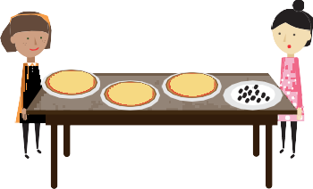*They want to put 3 or 4 olives on each pizza. Can we make a family of multiplication and division equations to help them?*

*12 12*



*4*

*4*

*4*

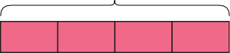

*3*

*3*

*3*

*3*

Pupils extend their understanding of division by relating the division facts to multiplication facts, creating a multiplication and division fact family. Word problems get increasingly more complex and bar models are used to represent problems involving division.

#### 



***4 times 3 is 12, so***

***12 divided by 3 is 4.***

***12 divided into groups of 4 is equal to 3.***



***3 times 4 is 12, so***

***12 divided by 4 is 3.***

***12 shared between***

***4 is equal to 3.***





Year 4

**Dividing by 6,**

7 and 9

*30 ÷ 6 = 5*

*6 × 5 = 30*

*Each packet can hold 5 pencils.*

Pupils are given division word problems and immediately relate the division used to solve the problem to the multiplication fact they have

previously learned. The language associated with division is given, with pupils understanding that when the number is divided, the outcome is called the quotient.

|  |  |  |  |  |
| --- | --- | --- | --- | --- |
|  |  |  |  |  |

Year 4

**Dividing by 11 and 12**



***When 30 is divided by 6,***

***the quotient is 5.***

*12 12 12 12 12*

*5 × 12 = ÷ 12 =*

*12 × 5 = ÷ 5 =*

Arrays and bar models are used to show the relationship between multiplication and division when learning to multiply and divide by 11 and 12, building on the relationship already learned when dividing by 6, 7 and 9.

*There are 13 flowers.*

Year 4 Dividing with Remainders

*13 ÷ 3 = 4 with 1 left over The quotient is 4.*

*The remainder is 1.*

Pupils learn that when dividing into equal groups, we can be left with a number of items less than the group size. This is introduced as the remainder.

Initially, the remainder is shown as a whole number.



Year 4

**Word Problems Involving Division**

*hat * *tennis racket*

*6 units £54*

|  |  |  |  |  |
| --- | --- | --- | --- | --- |
|  |  |  |  |  |

*1 unit £54 ÷ 6 = £9*

*£54*

Division word problems are supported by the use of arrays and bar models, reinforcing the idea of equal groups. Pupils relate the representations of the problems to the equations given. Comparison

division models are also used to determine amounts when two separate amounts are compared.



|  |  |  |  |
| --- | --- | --- | --- |
|  |  |  |  |



***12 ÷ 4 = 3***



|  |  |  |
| --- | --- | --- |
|  |  |  |

Year 4 Dividing by 1



***12 ÷ 3 = 4***



Pupils look for a pattern and generalise about dividing by 1. They systematically work through dividing a single amount by 4, 3, 2 and finally 1 to make observations about the number of groups and the size of each group.



***12 ÷ 2 = 6***



***12 ÷ 1 = 12***

Year 4

**Dividing 2-Digit Numbers**

*Step 1 Divide 4 tens by 2.*

|  |  |
| --- | --- |
| **10 10** |  |
| **10 10** |

*4 tens ÷ 2 = 2 tens*



*40 ÷ 2 = 20*

*Step 2 Divide 6 ones by 2.*



|  |  |
| --- | --- |
| **10 10** |  |
| **10 10** |  |

*6 ones ÷ 2 = 3 ones*



*6 ÷ 2 = 3*

*46 ÷ 2 = 23*



**100 100 100**



*20*

*2*

*4 6*

*2*

*− 4 0*

*2*

*2 3*

*4 6*

*− 4 0*

*6*

*6*

*0*

Pupils initially use place–value counters to support the division of 2-digit numbers, then move on to use a long formal written method. The long written

method shows the systematic division of parts of the dividend resulting in the quotient.

Year 4

**Dividing 3-Digit Numbers**

*306 ÷ 3 =*

The same procedure used for dividing 2-digit numbers is used for dividing 3-digit numbers. Place– value counters are used to represent the problem before moving on to use the long formal written method.

## Division Calculation Policy



### Year 5

**Year Topic/Strand Representation Key Idea**

Year 5 Finding Multiples

*4 rows of 8 stamps.*

*4 × 8 = 32*

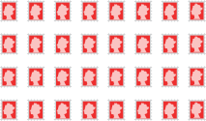

***A multiple is a number you get when you multiply one number by another number.***

***8, 16, 24, 32 and 40***

***are multiples of 8.***

Pupils use arrays to recognise multiples as the total number once a number is multiplied by another number. Skip counting is related to multiples as it is shown on a number line. Pupils also look for patterns when identifying multiples on number squares.

*8*

Year 5 Finding Factors



***3 and 8 are factors of 24.***

*3*

*3 rows of 8 tiles*

|  |  |  |  |  |  |  |  |
| --- | --- | --- | --- | --- | --- | --- | --- |
|  |  |  |  |  |  |  |  |
|  |  |  |  |  |  |  |  |
|  |  |  |  |  |  |  |  |

*3 × 8 = 24*



The same rectangular arrangement that was used to find multiples is used to identify factors. The pictorial representation leads to an understanding that factors are the numbers we multiply to produce a product.

Year 5

**Find Common Factors**

Pupils learn that when multiple numbers share the same factors, we can describe those factors as common factors. Pupils will begin to generalise about common factors. For example, all whole numbers ending in zero will have 5 as a multiple.



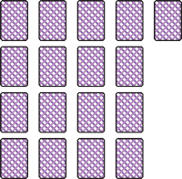*This is a rectangle.*

Year 5

**Prime and Composite Numbers**

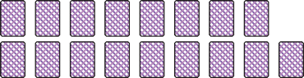

*These are not rectangles.*

*There is only one way to arrange 17 cards. 17 = 1 × 17*

*17 only has two factors, 1 and itself. 17 is a prime number.*

Pupils use their understanding of rectangular arrays to look for prime numbers. They learn that any number that can only be made into a single rectangular array is a prime number. In describing this array, they make the connection that prime numbers only ever have two factors, itself and 1. They also learn that numbers with two or more factors can be described as composite numbers.

*How many groups of 1000 can we make from 3564?*



***Look at the digit in the thousands place.***



Year 5 Dividing by 10,

**100 and 1000**

*3564*



**10 10 10**

**10 10 10**



*3000*

*564*

Place–value counters and numbers bonds are initially used to represent division problems involving dividing by 10, 100 and 1000.

Pupils use their understanding of place value to support the division calculations. For example, 35 hundreds ÷ 1 hundred = 35.

Year 5

**Dividing without Remainder**

*640*

*640*

*600 40*

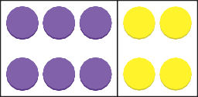

**1100000 1100000 1100000 10 10**

**1100000 1100000 1100000 10 10**

Pupils use place–value counters and number bond diagrams to support their understanding of the long formal written method for division. Pupils are shown how numbers can be partitioned into known multiples before carrying out the division.

Year 5 Dividing with Remainder

*7 8 remainder 1*

*6 4 6 9*

*− 4 2 0 420 ÷ 6 = 70*

*4 9*

*4 8 48 ÷ 6 = 8*

*1*

*1*

|  |  |  |  |  |  |
| --- | --- | --- | --- | --- | --- |
|  | | | | | |
|  |  |  |  |  |  |



*1 6*

*1 ÷ 6 = 1*

The same procedure used for dividing without a remainder is used for dividing with a remainder but once pupils have made the maximum possible number of equal groups, they have a quantity remaining that is less than the equal group size.

This is the remainder. Initially, the remainder is shown as a whole number. This progresses to showing

the remainder as a fraction. This progression is supported pictorially with a bar model. Pupils should also start to become aware that the representation of the remainder will be determined by the context of the problem.

*6 1*

*469 ÷ 6 = 78 6*

## Division Calculation Policy



### Year 6

**Year Topic/Strand Representation Key Idea**

Year 6 Order of Operations

*15 − 4 × 3 = 15 − 12*

*= 3*



***Follow the order***

***of operations. Multiply, then subtract.***

Pupils understand the order to calculate expressions and equations that have multiple operations.

Year 6

**Dividing by a**

2-Digit Number without Remainder

*450 ÷ 15 =*

*45 tens ÷ 15 = 3 tens*

*450 ÷ 15 = 30*

Pupils use simple division to help them calculate more complex division. Initially, pupils understand that if the dividend increases by a factor of 10 and the divisor remains the same, the quotient will also increase by a factor of 10. So, if 45 ÷ 15 = 3, then 450 ÷ 15 = 30.

Pupils also use their understanding of factors to divide. They progress to show division using a long formal written method. Once the long method is understood, pupils move on to divide using a short formal written method. While the process remains the same, the notation changes to keep it within the short division structure.



***450 = 45 tens***

*remainder 5*

*3 2*

*5 8 41*

*18*

*581*

*540 41*

The process used when dividing by a 2-digit number without a remainder stays the same when dividing with remainders. The process results in remainders that cannot be put into the equal group size as whole numbers. The context of the problem suggests



***Which division method do you prefer?***

Year 6

**Dividing by a**

2-Digit Number with Remainder

*30 × 18*

*36 5*

*2 × 18 remainder*

the form that the remainder will take and pupils decide on the best representation for the remainder depending on the context.

Pupils also use a unitary method of division to solve more complex word problems. Within these problems, they also use brackets to show the

partitioning of numbers and how this can be used to support calculation in division problems.

|  |  |  |  |  |  |  |  |  |  |  |  |  |
| --- | --- | --- | --- | --- | --- | --- | --- | --- | --- | --- | --- | --- |
| ***Multiples of 4*** | *4* | *8* | *12* | *16* | *20* | *24* | *28* | *32* | *36* | *40* | *44* | *48* |
| ***Multiples of 6*** | *6* | *12* | *18* | *24* | *30* | *36* | *42* | *48* | *54* | *60* | *66* | *72* |
| ***Multiples of 8*** | *8* | *16* | *24* | *32* | *40* | *48* | *56* | *64* | *72* | *80* | *88* | *96* |

Year 6 Common Multiples

Pupils work systematically through problems looking for common multiples of given numbers.



**compost compost compost compost compost compost compost compost compost compost compost compost compost compost compost compost compost compost**

*1 row of 18 bags*

*1 × 18 = 18*



**compost compost compost compost compost compost**

**compost compost compost compost compost compost**

**compost compost compost compost compost compost**

Year 6 Common Factors



**compost compost compost compost compost compost compost compost compost**

**compost compost compost compost compost compost compost compost compost**

*2 rows of 9 bags 3 rows of 6 bags*

*2 × 9 = 18 3 × 6 = 18*



***1, 2, 3, 6, 9 and 18***

***are factors of 18.***

Pupils use long division to find common factors of given numbers. The method used to find common factors progresses to arrays and using tables to systematically find possible common factors.

*Elliott has 7 square tiles.*

Year 6 Prime Numbers

*Elliott can only make 1 rectangular arrangement.*

*1 row of 7*

*1 × 7 = 7*

*The factors of 7 are 1 and 7. 7 is a* ***prime number****.*

Arrays are used as they have been previously, looking for rectangular patterns. Pupils see that numbers that can only be made into 1 rectangular arrangement are prime numbers with factors of itself and 1.

Dividing

*4*

|  |  |  |  |  |  |  |  |
| --- | --- | --- | --- | --- | --- | --- | --- |
|  |  |  |  |  |  |  |  |
|  |  |  |  |  |  |  |  |

*3 ÷ 4 =*

Pupils relate dividing fractions by a whole number to multiplying by its reciprocal. So, dividing by 4

is related to multiplying by 1 . We also read this

Year 6

**Fractions by** 1 4

Whole Numbers

*3 ÷ 4 = 1 × 3 = 3*

as ‘ 4 of’. The procedure of dividing fractions

by whole numbers is supported by the use of bar

*4 4 4 16* models and pictorial representation.

Dividing

*.*

*2 8 . 4 2*

*− 8*

*0 . 4*

*2 × 4*

Initially, place–value counters are used to show the division procedure that should be well known by pupils at this stage. The long formal written method is then used to divide decimal numbers without

Year 6

**Decimals without Renaming**

*− 0 . 4 2 × 0.2*

*0 . 0 2*

*− 0 . 0 2 2 × 0.01*

*0*

renaming the dividend. The procedure for long division does not change. Pupils need to be mindful of the placement of the digits and remember that the decimal point does not represent a place. Simply, the decimal point separates the whole and fractional parts of a number.

Year 6

**Dividing Decimals**

with Renaming

*6 ones*

*5 ones*

*5 ones*

*÷ 5*

*1 one*

*6.15*

*1 tenth*

*11 tenths*

*10 tenths*

*÷ 5*

*2 tenths*

*5 hundredths*

*5 hundredths*

*15 hundredths*

*÷ 5*

*3 hundredths*

Initially, place–value counters are used to show the division procedure that should be well known by pupils at this stage. The long formal written method is then used to divide decimal numbers without

a remainder. The procedure for long division with renaming does not change from what pupils have experienced previously. Pupils need to be mindful of the placement of the digits and remember that the decimal point does not represent a place. Simply, the decimal point separates the whole and fractional parts of a number.

*6.15 ÷ 5 = 1.23*

*4.65 kg ÷ 15 =*

*4.65*

#### 

Year 6

**Dividing Decimals by a 2-Digit**

Whole Number

*4.5*

*= 45 tenths*

*÷ 15*

*= 3 tenths*

*0.15*

*= 15 hundredths*

*÷ 15*

*= 1 hundredth*

Pupils initially divide decimal numbers by 2-digit

whole numbers where the dividend is easily broken into multiples of the divisor. Number bonds

demonstrate the partitioning in order to divide using long and short formal written methods of division.

*3 tenths + 1 hundredth = 0.3 + 0.01*

*= 0.31*

*4.65 ÷ 15 = 0.31*

Year 6 Ratio

*London plane sweet chestnut common lime*

*1890 trees*



***There are 9 parts in total. Divide 1890 by 9.***

|  |  |  |  |  |  |
| --- | --- | --- | --- | --- | --- |
|  |  |  |  |  |  |

Pupils use a unitary method involving division to determine quantities in ratio problems. This approach is supported by the use of bar models.

|  |  |  |  |
| --- | --- | --- | --- |
| ***x*** | *18* | *3* | *90* |
| ***x***  ***3*** |  |  |  |

Year 6 Algebra

Pupils use their understanding of division to determine unknown values with algebraic expressions and equations.